Six Decades of Human Spaceflight: A Reproducible Analysis of Global Participation, Career Duration, and the Commercial Inflection Point (1961–2026)
Dr. Richard Barker
AstroBotany Laboratory, Department of Botany, University of Wisconsin–Madison, Madison, WI, USA
MadWest Rocketry Education & Outreach Initiative · Correspondence: dr.richard.barker@wisc.edu
ABSTRACT
Over six decades since Yuriy Gagarin’s pioneering orbit in 1961, human spaceflight has transitioned from a high-risk Cold War geopolitical contest into a multi-national orbital laboratory era, and most recently into an expanding commercial enterprise. Here, we present a reproducible, census-level analysis of 773 flown astronauts spanning 1961 through 2026 (the catalogue's 783 flown astronauts minus the 10 still in space when the snapshot was taken, whose careers are not yet complete), derived from Jonathan C. McDowell’s General Catalogue of Astronauts.
Our findings reveal three distinct national operational philosophies: (1) the United States prioritised broad headcount participation (460 astronauts, 59.5% of the global total) characterized by relatively short mission spans (median career duration: 19.8 days); (2) Russia/USSR pursued sustained long-duration endurance (131 astronauts, 16.9%), yielding a median career duration of 194.8 days and the longest cumulative career on record (1,110.6 days, Oleg Kononenko); and (3) China established a deliberate, station-centric programme (27 astronauts, 3.5%) debuted entirely after 2003 with a median career duration of 192.2 days clustered in the 50-day to 1-year band.
Crucially, the 2020s has emerged as the most prolific debut decade in spaceflight history (199 new astronauts), surpassing the 1990s ISS build-up (168 debuts). However, this surge represents a profound structural bifurcation: 82.4% (637) achieved orbit, whereas 17.6% (136) flew exclusively on suborbital trajectories—driven predominantly by post-2021 commercial flights. Women comprise 14.7% (114 astronauts) of all space travelers.
Keywords: Astronaut Demographics · Human Spaceflight · Career Duration · Commercial Spaceflight · Orbital vs. Suborbital · Space Medicine
1. Introduction
Since the dawn of human space exploration with Vostok 1 and Mercury-Redstone 3 in 1961, human presence beyond Earth's atmosphere has served as a benchmark of technological capability, geopolitical prestige, and scientific discovery. In the initial decades of the Space Race, astronaut cohorts were drawn almost exclusively from elite military test pilot corps, operating within state-sponsored programmes driven by the Cold War rivalry between the United States and the Soviet Union.
The advent of the NASA Space Shuttle programme in 1981 and the construction of modular space stations—culminating in the continuous human occupation of the International Space Station (ISS) since November 2000 and the completion of the Chinese Tiangong Space Station—fundamentally transformed astronaut mission profiles. Concurrently, the post-2020 commercial spaceflight revolution has democratized suborbital access while creating a distinct demographic of commercial spaceflight participants.
In this study, we present a standardized, reproducible census of human space travelers from 1961 through 2026, analyzing career duration profiles, national operational paradigms, gender dynamics, and the structural implications of commercial suborbital flight.
2. Materials and Methods
Data were harvested from Jonathan C. McDowell's General Catalogue of Astronauts (Planet4589), an internationally recognized astronomical catalogue. The extraction pipeline (scripts/build_dataset.py) parses fixed-width biographical and mission catalogues (astro.html and missions.html). The snapshot is the catalogue as updated on 3 July 2026, which lists 783 flown astronauts; the 10 still in space when it was taken have no completed career duration and are excluded, leaving 773.
Astronauts are classified into four national cohorts (USA, Russia/USSR, China, and Other Nations) and categorized by orbital mechanics thresholds into Orbital (achieved stable orbit on at least one flight) vs. Suborbital (all flights suborbital). Career duration is partitioned into five operational bands: < 1 hour, 1 hour to 1 week, 1 week to 50 days, 50 days to 1 year, and > 1 year. The Russia/USSR cohort is catalogue citizenship code RU, which covers most Soviet-era cosmonauts; four Soviet cosmonauts coded UA or KZ (Dobrovol'skiy, Zholobov, Artsebarskiy, Aubakirov) fall under Other Nations.
3. Results
3.1 Global Spaceflight Growth and Decadal Dynamics
The analysed set comprises 773 individual astronauts who first flew between April 1961 and mid-2026. Debut trends exhibit clear historical waves corresponding to major launch vehicle architectures (Figure 1 and Table 1).
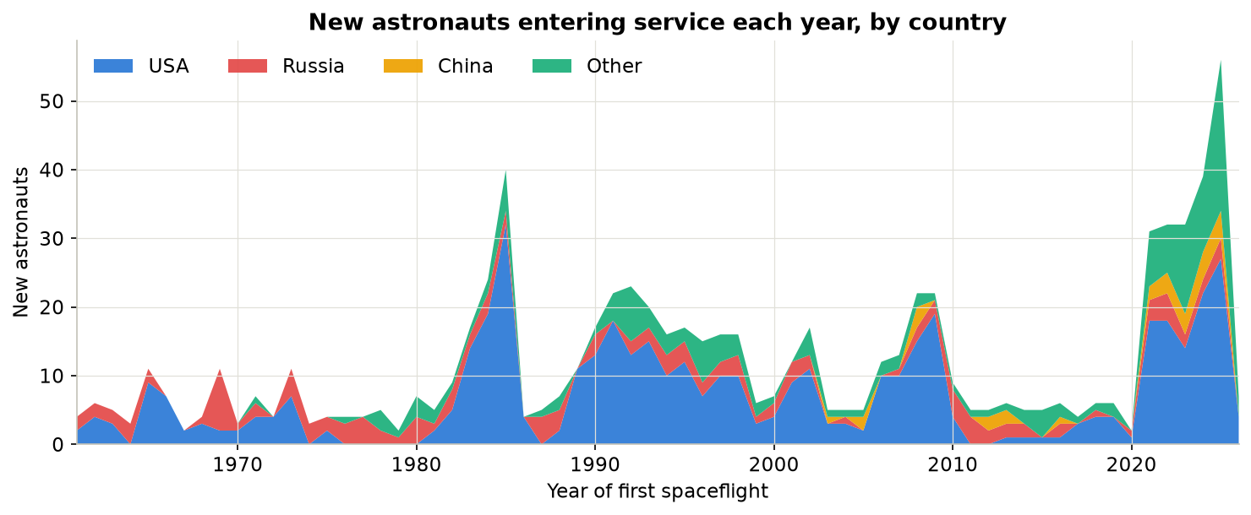
Figure 1 | New astronauts entering service each year by country (1961–2026). Stacked area timeline displaying USA (blue), Russia (red), China (yellow), and Other (green).
Decade | Total Debuts | USA | Russia / USSR | China | Other Nations
1960s | 53 | 32 | 21 | 0 | 0
1970s | 47 | 19 | 22 | 0 | 6
1980s | 129 | 89 | 22 | 0 | 18
1990s | 168 | 111 | 21 | 0 | 36
2000s | 120 | 86 | 13 | 6 | 15
2010s | 57 | 19 | 17 | 5 | 16
2020s | 199 | 104 | 15 | 16 | 64
Total | 773 | 460 | 131 | 27 | 155
3.2 National Operating Paradigms and Duration Fingerprints
Cumulative career duration reveals stark national divergence in operational culture (Figures 2, 3, and 4; Table 2):
• United States: 460 astronauts (59.5%), median career duration of 19.8 days. Driven by 7-person Space Shuttle crews and recent commercial suborbital flights.
• Russia / USSR: 131 cosmonauts (16.9%), median career duration of 194.8 days (~10x higher) and the world record career total of 1,110.6 cumulative days (Oleg Kononenko).
• China: 27 astronauts (3.5%), all post-2003 with a median career duration of 192.2 days, concentrating in 6-month Tiangong station increments.
• Other Nations: 155 astronauts (20.1%), exhibiting a median career duration of 9.1 days.
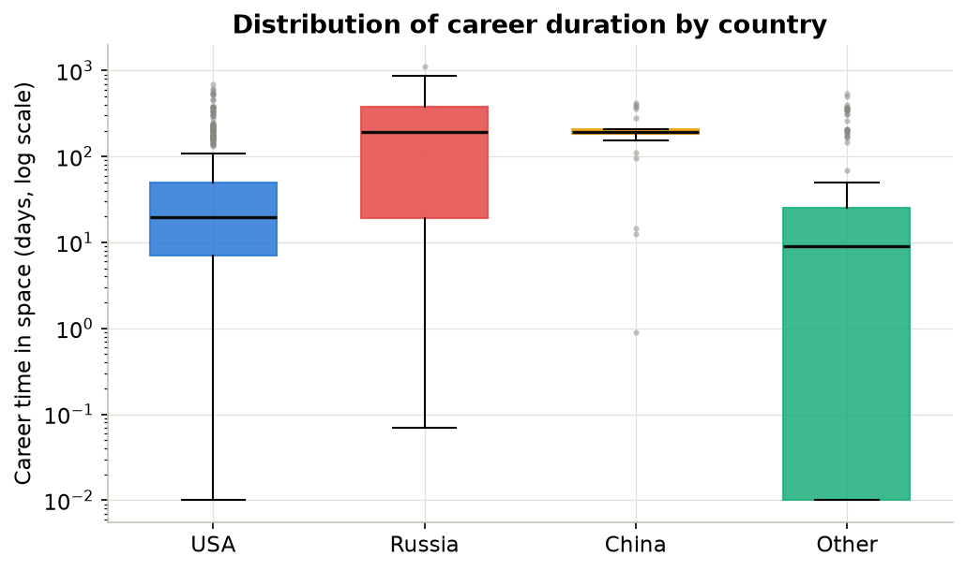
Figure 2 | Career time in space (days, log scale) by citizenship group.
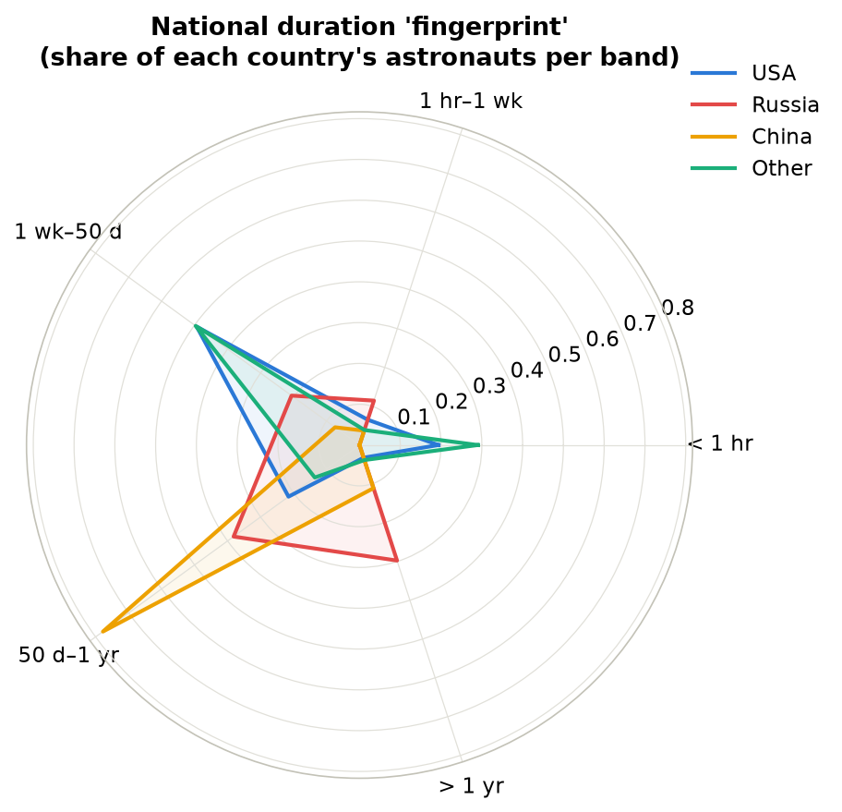
Figure 4 | Duration profile radar: normalized national fingerprints across the five duration bands.
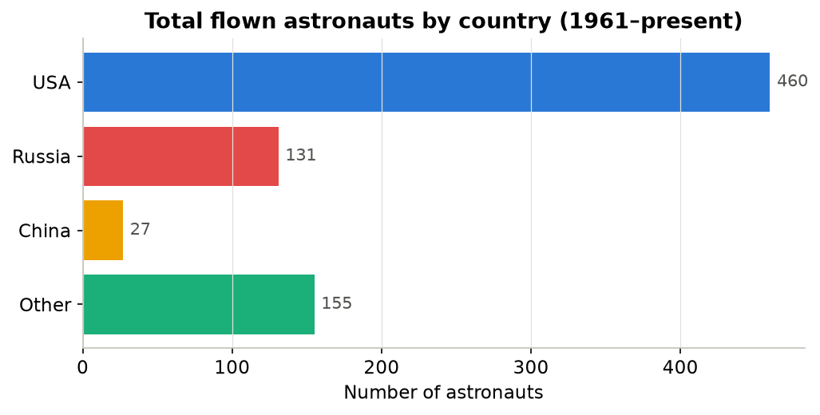
Figure 3 | Total flown astronauts by country (1961–2026).
Country | Astronauts | Global Share | Median Career (d) | Max Career (d)
USA | 460 | 59.5% | 19.8 | 695.3
Russia / USSR | 131 | 16.9% | 194.8 | 1,110.6
China | 27 | 3.5% | 192.2 | 418.6
Other Nations | 155 | 20.1% | 9.1 | 545.1
Overall Total | 773 | 100.0% | 21.2 | 1,110.6
3.3 The Commercial and Suborbital Inflection Point
Of 773 astronauts, 637 (82.4%) achieved orbit and 136 (17.6%) flew exclusively on suborbital trajectories (Figure 6, Table 3, Table 4). Crucially, 123 of the 136 suborbital flyers debuted in 2021 or later on commercial vehicles (Blue Origin New Shepard and Virgin Galactic); the other 13 are X-15 pilots (1962–67), SpaceShipOne pilots (2004) and Virgin Galactic test crew (2018–19). The Mercury suborbital astronauts Shepard and Grissom later reached orbit and are counted as Orbital. Suborbital flights are exclusively confined to the US (91 flyers) and international commercial guests (45 flyers); Russia and China have flown zero suborbital-only astronauts.
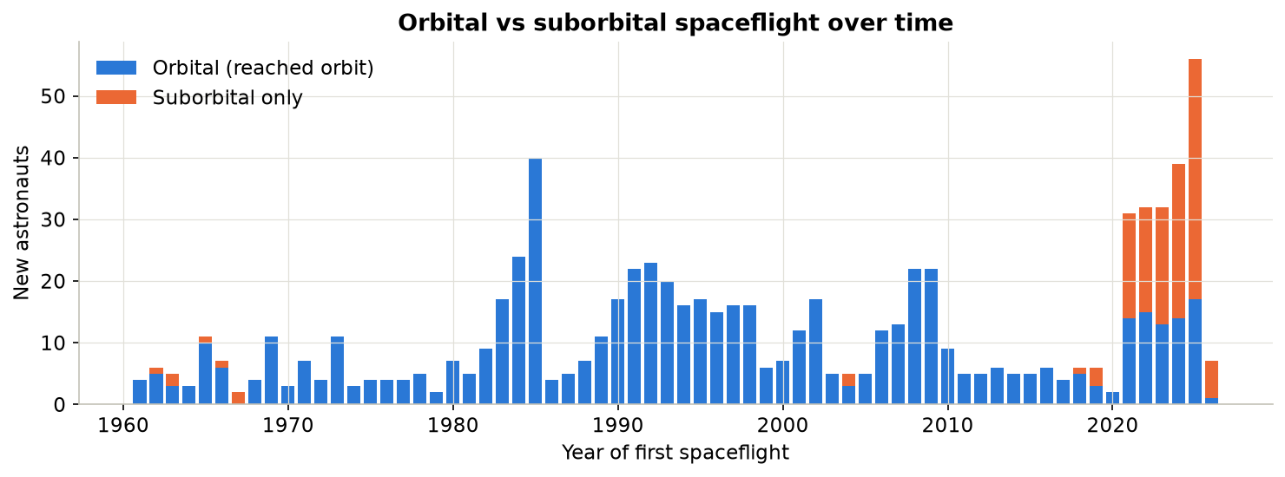
Figure 6 | Orbital vs. suborbital spaceflight debuts over time (1961–2026).
Nationality Group | Orbital Astronauts | Suborbital Only | Suborbital Proportion
USA | 369 | 91 | 19.8%
Russia / USSR | 131 | 0 | 0.0%
China | 27 | 0 | 0.0%
Other Nations | 110 | 45 | 29.0%
Global Total | 637 | 136 | 17.6%
3.4 Demographic Trends and Gender Representation
Women comprise 14.7% (114/773) of all flown astronauts (Figure 5). Female representation has risen from 0% in the 1970s to 25.1% in the 2020s, but remains far below gender parity. Peggy Whitson holds the record for the longest cumulative US career (695.3 days).
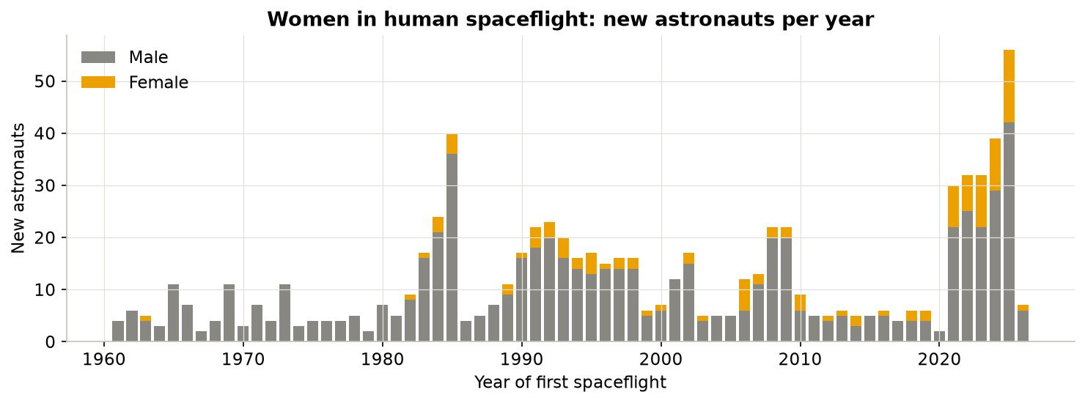
Figure 5 | Women in human spaceflight: new astronauts per year (1961–2026).
4. Discussion & Biomedical Implications
The structural bifurcation between short suborbital commercial hops and long-duration orbital expedition increments holds profound implications for aerospace medicine:
1. Occupational Radiation Exposure: Long-duration flyers (> 50 days; 254 astronauts) accumulate significant GCR doses, whereas suborbital participants receive negligible radiation.
2. SANS & Bone Demineralization: SANS and trabecular bone loss are associated mainly with extended microgravity stays, requiring rigorous countermeasure validation before Mars transit.
3. Future Commercial Stations: As private orbital stations replace the ISS post-2030, this baseline census provides demographic modeling parameters for commercial crew turnover.
5. Data Availability & Reproducibility
All data, code, and interactive dashboards are open-source at https://github.com/dr-richard-barker/Astronaut_trends and https://dr-richard-barker.github.io/Astronaut_trends/.
References
1. McDowell, J. C. (2026). General Catalogue of Astronauts. Planet4589 Space Lists. https://planet4589.org/space/astro/lists/
2. Crucian, B. E., et al. (2018). Immune System Dysregulation During Spaceflight: Potential Countermeasures for Deep Space Exploration Missions. Frontiers in Immunology, 9, 1437. https://doi.org/10.3389/fimmu.2018.01437

