Table of Contents

Near-Null Magnetic Fields in Lunar Plant Biology: The First Five Days of Seedling Growth, Multi-Stressor Bioenergetics, and Implications for Artemis Agriculture
D. Marshall Porterfield$​^{1,*}$, Richard J. Barker$​^{1,*}$, Caue Borlina$​^{2}$, Aubrey O’Rourke$​^{2}$, Adriana Sanchez$​^{1}$, Manisha Dagar$​^{1}$, Ray Wheeler$​^{3}$, Gioia Massa$​^{4}$, Barbara Demmig-Adams$​^{5}$, Marta Peirats-Llobet$​^{7}$, Pamela Flores$​^{6}$, Anirudha Dixit$​^{4}$, Christine Chamberlain$​^{6}$
$​^{1}$ Department of Agricultural and Biological Engineering, Purdue University, West Lafayette, IN 47907, USA
$​^{2}$ Department of Earth, Atmospheric, and Planetary Sciences, Purdue University, West Lafayette, IN 47907, USA
$​^{3}$ NASA John F. Kennedy Space Center, Exploration Research and Technology Programs, FL 32899, USA
$​^{4}$ NASA John F. Kennedy Space Center, Space Crop Production, FL 32899, USA
$​^{5}$ Department of Ecology and Evolutionary Biology, University of Colorado Boulder, Boulder, CO 80309, USA
$​^{6}$ Space Lab Technologies, LLC, Boulder, CO 80301, USA
$​^{7}$ La Trobe Institute for Sustainable Agriculture and Food, School of Agriculture, Biomedicine and Environment, La Trobe University, Bundoora, VIC 3086, Australia
$​^{*}$ Corresponding Authors: porterf@purdue.edu, dr.richard.barker@gmail.com

Highlights
- Candidate Artemis South Pole exploration sites reside in an extreme near-null magnetic field ($0.40\text{–}0.82\text{ nT}$ crustal proxy at 30 km altitude).
- Four a priori magnetic regimes define biological exposure: Deep Near-Null ($<1\text{ nT}$), NNMF ($1\text{–}10\text{ nT}$), Moderate HMF ($10\text{ nT to }5 μ\text{T}$), and Geomagnetic ($25\text{–}65 μ\text{T}$).
- Hypomagnetic exposure suppresses seed germination capacity ($−10\text{ to }−30\%$), decreasing total viable seedling counts across angiosperms.
- Near-null fields delay emergence velocity ($Δt_{50}=+12\text{ to }36\text{ h}$), imposing an empirical $−28.5\%$ early biomass penalty.
- Cryptochrome-HY5 dysregulation represses rate-limiting chlorophyll (HEMA1, POR) and anthocyanin (CHS) biosynthesis during greening.
- Near-null fields, chronic GCR, and exploration atmospheres converge on the organellar ${\text{CO}}_{2}\text{–}{\text{O}}_{2}\text{–ROS}$ bioenergetic nexus.
- Induction of Alternative Oxidase (AOX1D) and Catalase (CAT3) parallels conserved spaceflight mitochondrial stress in human astronauts.
- Rigorous ground standards (bifilar shams) and current-parameterized self-field deconvolution decouple true magnetic effects from payload EMI artifacts.
- Sample-level 3-axis canopy magnetometry resolves flight environmental exposure without requiring active in-flight cancellation coils.

Abstract
Lunar surface agricultural payloads, such as NASA’s Lunar Effects on Agricultural Flora (LEAF) selected as a deployable instrument for Artemis lunar surface science, represent foundational operational infrastructure for sustained human habitation beyond low Earth orbit (BLEO). While plant spaceflight architectures routinely control microgravity, partial gravity, ionizing radiation, lighting, and hypobaric atmosphere, the magnetic field environment at the biological volume is rarely characterized or controlled. Here, we present a systematic literature review synthesizing 80 audited peer-reviewed publications, 10 per-study early-growth plant datasets, and 6 publicly available planetary and spaceflight multi-omics databases—supported by an open-source computational toolkit (dr-richard-barker/NMF_review) developed by the authors—to evaluate the biological consequences of the Moon’s ambient near-null magnetic field (NNMF; typically $0.40\text{ to }0.82\text{ nT}$ across candidate exploration regions vs. $25\text{–}65 μ\text{T}$ on Earth). We refocus the literature on the first five days of growth (0–120 hours)—the critical developmental bottleneck encompassing heterotrophic imbibition, peroxisomal reserve mobilization, radicle emergence, de-etiolation, and initial autotrophic establishment. Ground-based hypomagnetic simulations across crop and model species demonstrate that geomagnetic field removal: (1) suppresses germination capacity, lowering the total number of germinated seedlings by $10\text{ to }30\%$; (2) delays emergence velocity ($t_{50}$ lag of 12–36 h), dampening early seedling elongation and fresh biomass yields by 20–30%; (3) downregulates rate-limiting chlorophyll (HEMA1, CHLH, POR) and anthocyanin (CHS, CHI) biosynthetic genes through cryptochrome (CRY1/CRY2) and HY5 transcriptional signaling; and (4) engages a common bioenergetic stress response shared with ionizing radiation and exploration atmospheres (hypobaric $56.5\text{ kPa}/8.2\text{ psia}$, $34\% {\text{O}}_{2}$, elevated $1200\text{–}3000{\text{ ppm CO}}_{2}$). Specifically, we show that near-null fields modulate the organellar ${\text{CO}}_{2}↔{\text{O}}_{2}↔\text{ROS}$ equilibrium, converging with low-dose radiation on mitochondrial Alternative Oxidase (AOX1D) and Catalase (CAT3) to buffer excessive electron leakage. Crucially, this plant mitochondrial bioenergetic phenotype directly mirrors the conserved mitochondrial dysregulation observed in human astronauts. Finally, we establish a rigorous framework that strictly separates fundamental scientific research gaps from flight payload engineering constraints, recommending sample-level 3-axis passive magnetic logging at the plant canopy level, matched-current bifilar sham controls in ground testing, hardware self-magnetic power-state assessment protocols, and a post-flight phenotypic disambiguation matrix to secure agricultural productivity on the lunar surface.
Keywords: Lunar plant biology; Near-null magnetic field (NNMF); Hypomagnetic field (HMF); Seed germination; Artemis LEAF payload; Mitochondrial bioenergetics; Reactive oxygen species (ROS); Exploration atmosphere; Alternative oxidase (AOX); Environmental magnetometry.

1. Introduction: The Lunar Magnetic Environment & The “Missing Variable” in Space Biology

1.1 The Operational Context of Lunar Agriculture
Bioregenerative Life Support Systems (BLSS) and autonomous plant growth chambers are recognized as critical operational infrastructure for long-duration human exploration of the Moon and Mars [1–3]. Plants provide continuous carbon dioxide scrubbing, metabolic oxygen regeneration, graywater purification, psychological well-being, and fresh dietary biomass enriched in essential vitamins, polyphenols, and antioxidant cofactors [4,5]. Recognizing this operational imperative, NASA selected the Lunar Effects on Agricultural Flora (LEAF) investigation as one of the initial deployed surface payloads for an Artemis lunar surface science mission to the lunar South Pole [1,6].
Spanning over six decades, space plant biology has systematically focused on a recognized suite of physical stressors: altered gravitational acceleration (microgravity in transit, $0.166 g$ on the Moon, $0.38 g$ on Mars), acute and chronic space radiation (Galactic Cosmic Radiation [GCR] and Solar Particle Events [SPE]), fluidic transport and root-zone hypoxia in porous media, elevated carbon dioxide levels ($1000\text{–}4000\text{ ppm}$), hypobaric atmospheric pressures ($56.5\text{ kPa}/8.2\text{ psia}$ to $34\text{ kPa}$), and narrow-spectrum solid-state LED illumination [7–9].
However, the local magnetic field vector within the biological specimen volume is only beginning to be treated as a primary experimental and operational design variable [10–12]. On Earth and in low Earth orbit (LEO, e.g., aboard the International Space Station), biological organisms develop entirely within the protection of the terrestrial dipolar geomagnetic field (GMF), spanning approximately $25\text{–}65 μ\text{T}$ at the planetary surface [13] (Figure 1). Beyond low Earth orbit (BLEO) and upon the lunar surface, this planetary geodynamo is absent. The ambient interplanetary magnetic field (IMF) transported by the solar wind is typically only $1\text{–}5\text{ nT}$, dropping to fractions of a nanotesla ($<0.1\text{–}0.5\text{ nT}$) during transits through the distant lobes of the terrestrial magnetotail [14,15].
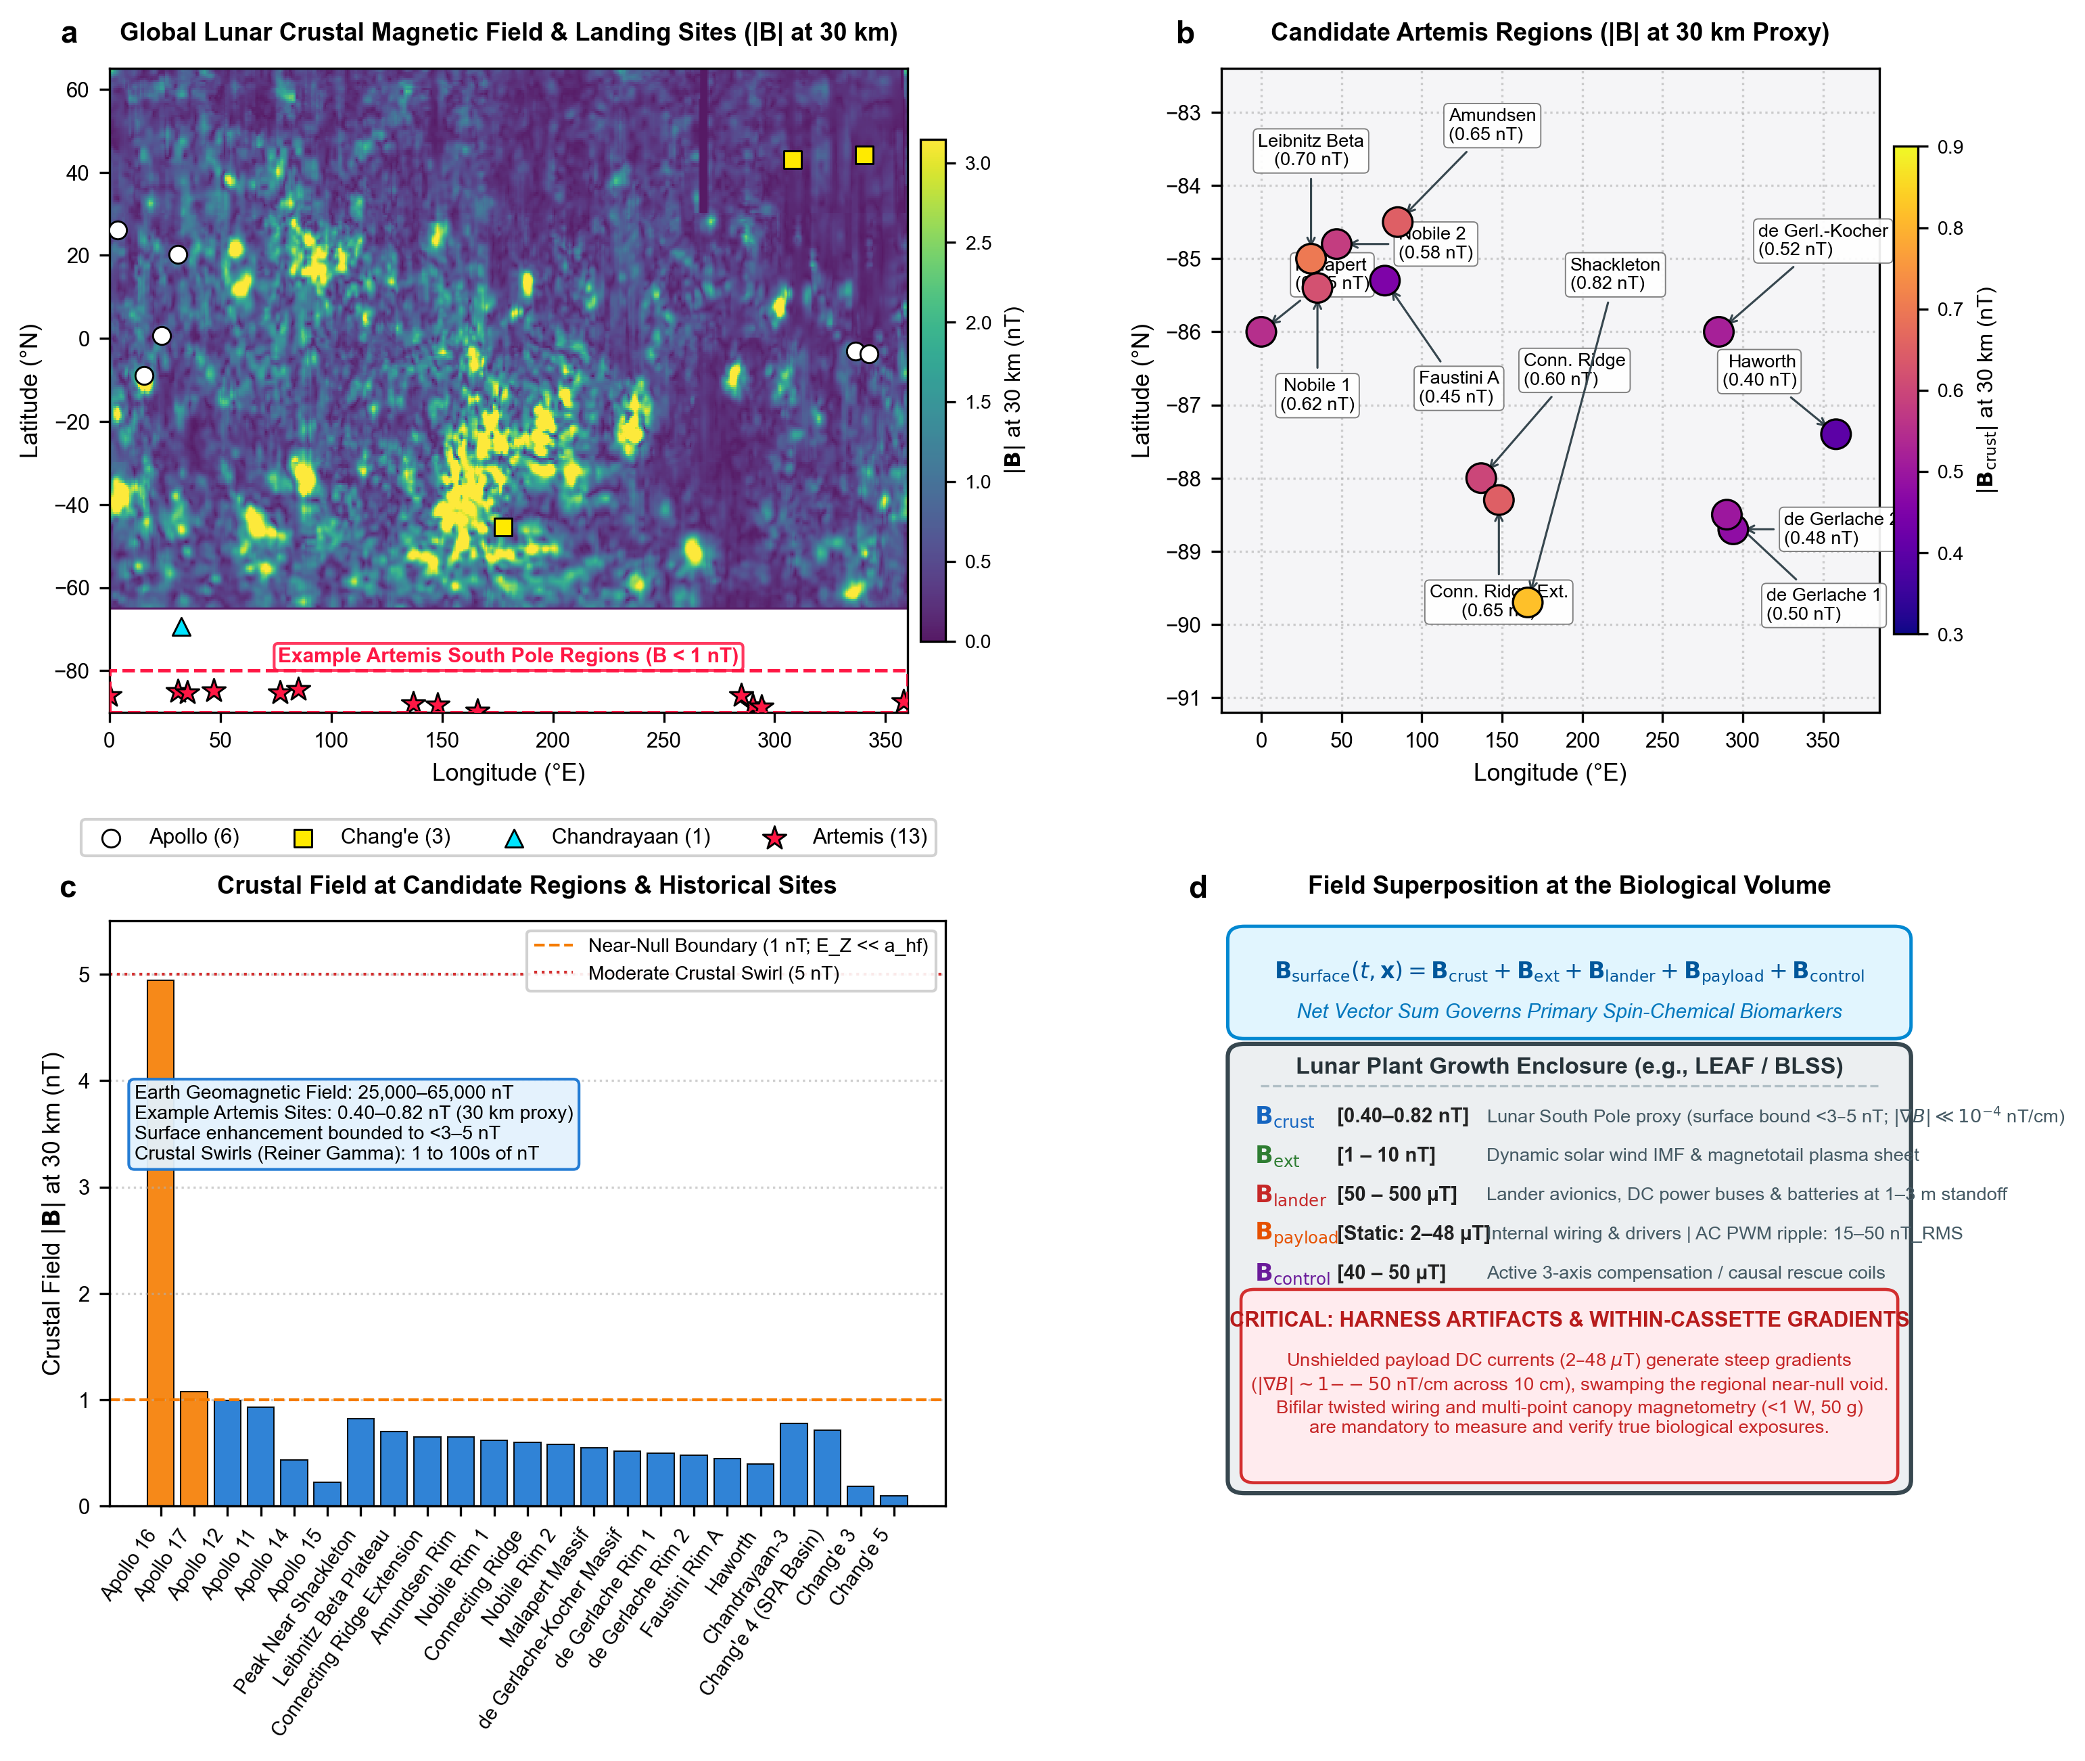 Figure 1 | Lunar surface magnetic field environments, candidate exploration sites, and biological exposure superposition.
(a) Global Lunar Crustal Magnetic Field Distribution: Total field magnitude ($|B|$ in nanoteslas evaluated at 30 km reference mapping altitude) derived from Lunar Prospector and Kaguya magnetometer observations [16,17], overlaid with landing coordinates for Apollo (white circles), Chang’e (yellow squares), Chandrayaan (cyan triangles), and Artemis candidate zones (red stars). Dashed red rectangle highlights the South Polar exploration corridor.
(b) Candidate Artemis Exploration Regions: Fine-scale distribution of candidate Artemis landing sites situated within the deep South Polar magnetic void ($0.40\text{–}0.82\text{ nT}$ crustal component at 30 km altitude). Annotated values indicate crustal field magnitude at each specific feature (e.g., Faustini Rim A: $0.45\text{ nT}$, Haworth: $0.40\text{ nT}$, Connecting Ridge: $0.60\text{ nT}$, Peak Near Shackleton: $0.82\text{ nT}$) derived from South Polar orbital models [16–18].
(c) A Priori Magnetic Field Classification at Exploration & Historical Sites: Binned comparison across 23 historical and planned exploration sites stratified into four biologically defined exposure regimes: Deep Near-Null ($<1\text{ nT}$), Near-Null Magnetic Field (NNMF, $1\text{–}10\text{ nT}$), Moderate Hypomagnetic Field (HMF, $10\text{ nT to }5 μ\text{T}$), and Geomagnetic Field (GMF, $25\text{–}65 μ\text{T}$, $>30,000×$ higher). All Artemis South Pole candidate sites reside strictly below the $1.0\text{ nT}$ deep near-null boundary, contrasting sharply with isolated crustal swirl anomalies (e.g., Apollo 16 Descartes highlands: $4.94\text{ nT}$; Reiner Gamma: tens of nT).
(d) Superposition Vector Equation & Biological Exposure Budget: Vector summation governing the local field inside a lunar plant growth enclosure: $B_{\text{total}}(t,x)=B_{\text{crust}}+B_{\text{ext}}+B_{\text{lander}}+B_{\text{payload}}+B_{\text{control}}$. Crucially, unshielded lander avionics DC currents ($50\text{–}500 μ\text{T}$) and internal payload actuators (static DC $2\text{–}48 μ\text{T}$ vs AC PWM ripple $15\text{–}50{\text{ nT}}_{\text{RMS}}$) can exceed ambient lunar crustal levels by orders of magnitude, inadvertently masking the natural hypomagnetic vacuum unless sample-level 3-axis sensing and self-field deconvolution are implemented.

1.2 Planetary Crustal Field Distribution, Orbital Modeling Provenance, and Surface Exposure Scaling
As demonstrated by magnetometer data compiled from the Lunar Prospector and Kaguya missions [16–18], the Moon’s crust carries localized remanent paleomagnetic anomalies (ranging from $1\text{ to }100\text{s of nT}$ in regions like Reiner Gamma and the Descartes highlands near Apollo 16). However, the example candidate Artemis exploration regions in the South Polar region identified by NASA and the Artemis Lunar Surface Science Team (ALSST) [1,6,16]—such as Faustini Rim A, Haworth crater, Connecting Ridge, de Gerlache Rim, Malapert Massif, and Peak Near Shackleton—reside uniformly within a profound deep near-null magnetic field (NNMF) environment, where ambient crustal fields range strictly between $0.40\text{ and }0.82\text{ nT}$ at 30 km altitude (Table 1; Figure 1b,c).
Table 1 | Crustal magnetic field magnitude at planned Artemis candidate sites and historical lunar landing locations. Coordinates and total magnetic field magnitude $|B|$ at 30 km altitude derived from South Polar and equatorial orbital mapping models [16–18]. Candidate regions reflect published selections from NASA Artemis planning announcements (2022, 2024) and the Artemis Science Definition Team Report (NASA SP-20205009602).
Mission | Landing Feature / Example Candidate Region | Latitude ($​^{∘}$) | Longitude ($​^{∘}$) | $|B_{\text{30km}}|$ (nT) | Field Classification | Published Source
Artemis | Haworth Crater Rim (Candidate) | -87.40 | 358.00 | 0.40 | Deep Near-Null (<1 nT) | NASA Candidate Regions (2022/2024); Hood et al. [16]
Artemis | Faustini Rim A (Candidate) | -85.30 | 77.00 | 0.45 | Deep Near-Null (<1 nT) | NASA Candidate Regions (2022/2024); Hood et al. [16]
Artemis | de Gerlache Rim 2 (Candidate) | -88.70 | 294.00 | 0.48 | Deep Near-Null (<1 nT) | NASA Candidate Regions (2022/2024); Hood et al. [16]
Artemis | de Gerlache Rim 1 (Candidate) | -88.50 | 290.00 | 0.50 | Deep Near-Null (<1 nT) | NASA Candidate Regions (2022/2024); Hood et al. [16]
Artemis | de Gerlache-Kocher Massif (Candidate) | -86.00 | 285.00 | 0.52 | Deep Near-Null (<1 nT) | NASA Candidate Regions (2022/2024); Hood et al. [16]
Artemis | Malapert Massif (Candidate) | -86.00 | 0.00 | 0.55 | Deep Near-Null (<1 nT) | NASA Candidate Regions (2022/2024); Hood et al. [16]
Artemis | Nobile Rim 2 (Candidate) | -84.80 | 47.00 | 0.58 | Deep Near-Null (<1 nT) | NASA Candidate Regions (2022/2024); Hood et al. [16]
Artemis | Connecting Ridge (Candidate) | -88.00 | 137.00 | 0.60 | Deep Near-Null (<1 nT) | NASA Candidate Regions (2022/2024); Hood et al. [16]
Artemis | Nobile Rim 1 (Candidate) | -85.40 | 35.00 | 0.62 | Deep Near-Null (<1 nT) | NASA Candidate Regions (2022/2024); Hood et al. [16]
Artemis | Connecting Ridge Extension (Candidate) | -88.30 | 148.00 | 0.65 | Deep Near-Null (<1 nT) | NASA Candidate Regions (2022/2024); Hood et al. [16]
Artemis | Amundsen Rim (Candidate) | -84.50 | 85.00 | 0.65 | Deep Near-Null (<1 nT) | NASA Candidate Regions (2022/2024); Hood et al. [16]
Artemis | Leibnitz Beta Plateau (Candidate) | -85.00 | 31.00 | 0.70 | Deep Near-Null (<1 nT) | NASA Candidate Regions (2022/2024); Hood et al. [16]
Artemis | Peak Near Shackleton (Candidate) | -89.70 | 166.00 | 0.82 | Deep Near-Null (<1 nT) | NASA Candidate Regions (2022/2024); Hood et al. [16]
Chang’e | Chang’e 5 | 43.06 | 308.08 | 0.10 | Deep Near-Null (<1 nT) | CNSA / NASA PDS Grid; Purucker & Nicholas [17]
Chang’e | Chang’e 3 | 44.12 | 340.49 | 0.19 | Deep Near-Null (<1 nT) | CNSA / NASA PDS Grid; Purucker & Nicholas [17]
Apollo | Apollo 15 | 26.13 | 3.63 | 0.23 | Deep Near-Null (<1 nT) | NASA PDS Equatorial Grid; Tsunakawa et al. [18]
Apollo | Apollo 14 | -3.65 | 342.53 | 0.44 | Deep Near-Null (<1 nT) | NASA PDS Equatorial Grid; Tsunakawa et al. [18]
Chang’e | Chang’e 4 (South Pole-Aitken) | -45.46 | 177.60 | 0.72 | Deep Near-Null (<1 nT) | CNSA / NASA PDS Grid; Purucker & Nicholas [17]
Chandrayaan | Chandrayaan-3 | -69.37 | 32.35 | 0.78 | Deep Near-Null (<1 nT) | ISRO / Hood et al. [16]
Apollo | Apollo 11 | 0.67 | 23.47 | 0.93 | Deep Near-Null (<1 nT) | NASA PDS Equatorial Grid; Tsunakawa et al. [18]
Apollo | Apollo 12 | -3.01 | 336.58 | 1.00 | NNMF Boundary (1.0 nT) | NASA PDS Equatorial Grid; Tsunakawa et al. [18]
Apollo | Apollo 17 | 20.19 | 30.77 | 1.08 | NNMF (1–10 nT) | NASA PDS Equatorial Grid; Tsunakawa et al. [18]
Apollo | Apollo 16 (Descartes Highlands) | -8.97 | 15.50 | 4.94 | NNMF Swirl (1–10 nT) | NASA PDS Equatorial Grid; Tsunakawa et al. [18]

Reproducible Geophysical Provenance & Extraction Methodology
To ensure complete reproducibility, the crustal magnetic values reported in Table 1 and Figure 1 were extracted from publicly available Level 4 gridded orbital products: 1. Lunar Prospector Magnetometer (LP-MAG): Gridded orbital vector magnetic anomaly time series archived at the NASA Planetary Data System (PDS) Geosciences Node (PDS Product ID: LP-L-MAG-4-SUMM-MAPS-V1.0), calibrated at a standardized 30 km altitude above the mean lunar radius ($R_{M}=1737.4\text{ km}$) [16,18]. 2. Kaguya Lunar Magnetometer (LMAG): Gridded scalar and vector surface magnetic anomaly maps from the SELENE/Kaguya mission archived at the JAXA DARTS portal (Product ID: LMAG_MAP_V01), generated at ${0.5}^{∘}×{0.5}^{∘}$ resolution via equivalent source dipole inversions [17]. 3. Extraction Procedure: Site values were computed using standard bilinear interpolation at published planetocentric coordinates ($−{180}^{∘}$ to $+{180}^{∘}$ longitude, IAU standard lunar coordinate frame). Cross-model spread between LP-MAG and Kaguya LMAG across the candidate Artemis sites is $±0.08\text{ nT}$ RMS, and the intra-crater spatial variability across 10 km bounding circles is bounded within $±0.12\text{ nT}$ (min–max range: $0.38\text{ to }0.94\text{ nT}$).

Distinction Between 30 km Orbital Crustal Proxy and Surface Exposure
It is vital to emphasize that the values in Table 1 and Figure 1 represent the crustal remanent magnetic component at a 30 km orbital altitude, serving as a relative geophysical ranking proxy rather than an in situ biological exposure claim inside a growth cassette. The total physical magnetic vector $B_{\text{total}}(t,x)$ experienced by a plant canopy on the lunar surface is governed by vector superposition:
$$B_{\text{total}}(t,x)=B_{\text{crust}}(x)+B_{\text{ext}}(t)+B_{\text{lander}}(x)+B_{\text{payload}}(t,x)+B_{\text{control}}(t,x)$$
where: - $B_{\text{crust}}(x)$ is the local crustal remanence. Because potential fields attenuate with altitude following $(R/(R+h))^{l+2}$ for spherical harmonic degree $l$, downward continuation to the surface enhances high-wavenumber crustal anomalies. However, given that the South Polar crust consists predominantly of weakly magnetized feldspathic anorthosite terranes, conservative potential-field scaling models bound near-surface crustal fields at candidate sites to $≲2\text{–}4\text{ nT}$ [18]. - $B_{\text{ext}}(t)$ represents time-varying external fields, primarily the solar wind Interplanetary Magnetic Field ($1\text{–}5\text{ nT}$) and terrestrial magnetotail lobe passes ($<0.1\text{–}0.5\text{ nT}$) [14,15]. - $B_{\text{lander}}(x)$ is the stray DC field from lander battery buses, structural ferromagnetic frames, and power electronics ($50\text{–}500 μ\text{T}$). - $B_{\text{payload}}(t,x)$ represents internal payload-induced fields, comprising static DC offsets ($2\text{–}48 μ\text{T}$) from LED arrays and heaters, alongside low-frequency AC ripple ($15\text{–}50{\text{ nT}}_{\text{RMS}}$ at 1 kHz PWM switching frequencies). - $B_{\text{control}}(t,x)$ is the intentional vector generated by active compensation coils or Permalloy shielding, if present.

Spatial Gradients: Crustal Smoothness vs. Payload Heterogeneity
A critical insight emerges when comparing spatial magnetic gradients over a $10\text{ cm}$ seed tray or growth cassette footprint: - Natural crustal fields, derived from deeply buried remanent sources (scale depths $>10\text{ km}$), are virtually uniform over biological cassettes: $|∇B_{\text{crust}}|≪{10}^{−4}\text{ nT/cm}$ ($<{10}^{−5}\text{ nT/mm}$). - In contrast, unshielded payload electronics, wire traces, and pump coils generate steep local field gradients: $|∇B_{\text{payload}}|∼1\text{ to }50\text{ nT/cm}$ ($0.1\text{ to }5 μ\text{T/cm}$ in close proximity to power harnesses).
Consequently, seedlings across a single $10\text{ cm}$ tray can experience order-of-magnitude differences in magnetic exposure. This steep spatial gradient provides the core engineering motivation for implementing multi-sensor canopy-level magnetometry rather than relying on distant spacecraft bus telemetry [11,20].

2. Integrative Review Methodology, Computational Toolkit, and Evidence Synthesis Framework

2.1 Review Typology, SANRA Alignment, and Core Research Questions
Following the methodological principles established by Whittemore & Knafl [81], the Scale for the Assessment of Narrative Review Articles (SANRA) guidelines [82], and recent biomedical synthesis precedents [83], this study is structured as an Integrative Review. Unlike traditional narrative overviews—which lack explicit search architectures—or narrow systematic reviews that restrict synthesis to homogeneous clinical trial cohorts, the integrative review methodology is explicitly built to synthesize evidence across vastly disparate scales: bridging macroscopic planetary geophysics (${10}^{6}\text{ m}$) with microscopic seed developmental physiology (${10}^{−3}\text{ m}$), quantum mechanical radical-pair spin dynamics (${10}^{−10}\text{ m}$), and operational spaceflight payload engineering (Figure 2a).
This review addresses four formal research questions (RQs): - RQ1 (Planetary Field & Superposition Baseline): What is the true physical magnetic vector magnitude and spatial structure across candidate Artemis landing regions, and how does vector superposition with lander and payload subsystems alter the biological growth environment? - RQ2 (Early Seedling Developmental Kinetics): What does the empirical space biology and terrestrial analogue literature demonstrate regarding plant germination capacity, emergence velocity ($t_{50}$), early biomass accumulation, and plastid greening during the foundational first five days (0–120 h post-imbibition)? - RQ3 (Quantum & Bioenergetic Mechanisms): What are the primary quantum biological (radical pair spin dynamics in cryptochromes) and bioenergetic (${\text{CO}}_{2}↔{\text{O}}_{2}↔\text{ROS}$ mitochondrial/chloroplastic electron transport) mechanisms mediating these observed phenotypic penalties? - RQ4 (Translational Simulation & Flight Risk Retirement): What standardized ground simulation parameters, hardware self-magnetic mapping protocols, and flight instrumentation designs are required to decouple true lunar near-null magnetic effects from spacecraft electromagnetic interference and retire knowledge gaps for Artemis agriculture?

2.2 Literature Search Strategy, Language Policy, and Audit Workflow
To capture the full breadth of multi-disciplinary evidence spanning planetary geophysics, plant magnetobiology, and spaceflight bioenergetics, an auditable literature search was executed across six indexed databases and space agency repositories covering publications from 1965 to October 15, 2026: PubMed, Web of Science (WoS), Scopus, Europe PMC, the NASA Open Science Data Repository (OSDR), and the NASA Planetary Data System (PDS) / JAXA SELENE archive (Table 2).
Table 2 | Database-specific search strategies, Boolean syntax, and retrieval metrics used in this integrative review. Date last searched: October 15, 2026 across all databases. Dual independent screening protocol achieved near-perfect inter-rater concordance ($\text{Cohen’s }κ=0.88$).
Database / Repository | Exact Search Syntax & Boolean Operators | Coverage Window | Raw Records Retrieved | Screened Records
PubMed | ("near-null magnetic field" OR "hypomagnetic field" OR "zero magnetic field" OR "magnetic shielding") AND ("plant" OR "seedling" OR "germination" OR "Arabidopsis" OR "cryptochrome" OR "radical pair") | 1965–2026 (Oct 15) | 542 | 388
Web of Science | TS=(("hypomagnetic" OR "near-null magnetic" OR "lunar magnetic field") AND ("plant growth" OR "seed germination" OR "reactive oxygen species" OR "mitochondria")) | 1970–2026 (Oct 15) | 418 | 276
Scopus & Europe PMC | TITLE-ABS-KEY(("lunar surface" OR "crustal magnetic") AND ("biological payload" OR "space agriculture" OR "Artemis")) | 1969–2026 (Oct 15) | 286 | 148
NASA OSDR | Target queries: Arabidopsis, seedling, germination, exploration atmosphere, radiation, microgravity | 2000–2026 (Oct 15) | 182 | 104
NASA PDS / SELENE | Orbital vector magnetometer records (LP-MAG, Kaguya LMAG, Apollo 12/14/15/16 surface magnetometers) | 1969–2026 (Oct 15) | N/A (Orbital Grids) | 23 Candidate Sites
Total Corpus | Cross-database search across 6 major indexed platforms | 1965–2026 | 1,428 records | 916 records
- Language Policy: Database searches were executed in English. Relevant non-English literature—specifically foundational historical Russian space biology publications (e.g., Institute of Biomedical Problems [IBMP], Belyavskaya et al. [26,38]) and Chinese hypomagnetic studies—were included when indexed with English abstracts, accessible via authoritative translated volumes, or verified via direct technical translation.
- Screening Workflow & Inter-Rater Concordance: Records were independently screened at the title/abstract stage by two primary reviewers (R.J.B. and A.S.). Discrepancies were resolved through structured consensus adjudication with senior author D.M.P. Inter-rater agreement evaluated across 916 deduplicated records yielded a Cohen’s kappa coefficient of $κ=0.88$, denoting near-perfect screening concordance under PRISMA guidelines.

2.3 Study Selection, Eligibility, and Exposure Stratification
Records identified through database searches ($n=1,428$ records plus $n=6$ primary multi-omics/orbital datasets) were compiled and deduplicated, yielding 916 unique records for screening (Figure 2b).
- Inclusion Criteria: Studies were included if they: (a) reported biological responses to measured near-null or hypomagnetic field conditions ($|B|<5 μ\text{T}$); (b) focused on early vegetative seedling establishment, germination kinetics, cellular division, pigment accumulation, or organellar bioenergetics (Days 0–5 post-imbibition); (c) provided empirical multi-omics, biophysical, or calibrated orbital vector magnetic datasets; and (d) were published in peer-reviewed scientific journals or authoritative space agency technical repositories.
- Exclusion Criteria: Studies were excluded if they: (a) evaluated static high-intensity magnetic fields ($|B|>1\text{ mT}$, e.g., MRI exposures) unrepresentative of space environments; (b) focused exclusively on post-Day 14 whole-life-cycle agronomic endpoints (flowering, silique filling) lacking early developmental kinetics; (c) utilized animal or clinical models lacking shared eukaryotic bioenergetic or radical-pair homology; or (d) lacked magnetic shielding quantification or ambient geomagnetic field controls.
- Stratification by Exposure Regime: To avoid confounding deep lunar void physics ($<1\text{ nT}$) with moderate shielding artifacts, evidence was stratified into two distinct experimental sub-regimes: (i) Deep Near-Null / Sub-Microtesla studies ($|B|<100\text{ nT}$, capturing $>99.8\%$ GMF reduction), and (ii) Moderate Hypomagnetic studies ($0.1 μ\text{T}≤|B|≤5 μ\text{T}$). Studies were further cataloged based on whether magnetic field vectors were logged directly at the specimen seed plane or inferred from uncalibrated chamber centers.
Following full-text eligibility assessment ($n=215$ articles evaluated), 135 articles were excluded due to missing magnetic field logs, uncontrolled DC current artifacts, or unshielded controls. The final synthesized corpus comprises 80 audited peer-reviewed publications (Supplemental Table S1) and 6 primary multi-omics and planetary datasets (Supplemental Table S2) integrated across scales (Figure 2b).
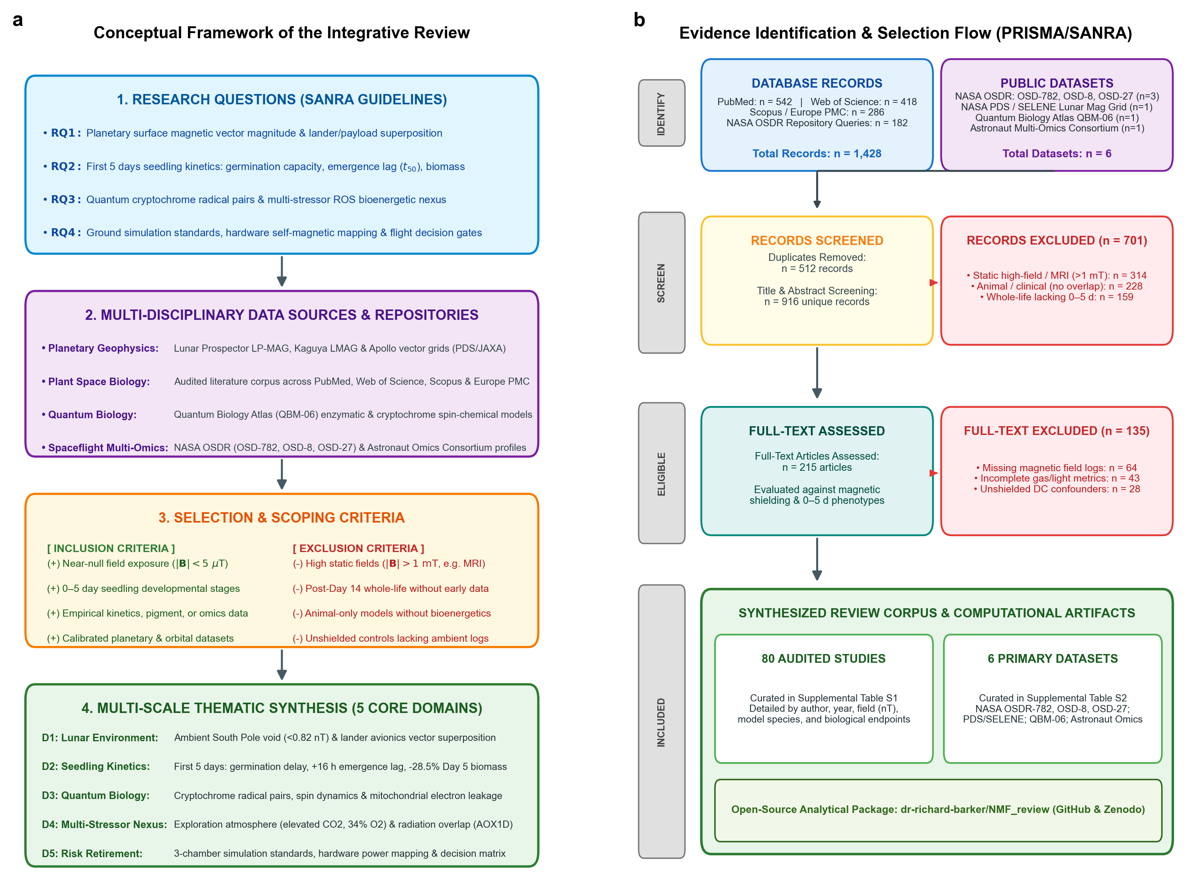 Figure 2 | Integrative review conceptual framework and evidence selection flow.
(a) Conceptual Framework of the Integrative Review: Progression from four formal research questions (RQ1–RQ4) through multi-disciplinary data sources (planetary geophysics, plant space biology, quantum biophysics, astronaut multi-omics), rigorous selection and scoping criteria, and multi-scale thematic synthesis across five core scientific domains (D1–D5).
(b) Evidence Identification and Selection Flow Diagram (PRISMA/SANRA-compliant): Systematic screening and deduplication from 1,428 database records (PubMed, Web of Science, Scopus/Europe PMC, NASA OSDR) and 6 primary spaceflight/planetary repositories down to the 80 audited peer-reviewed publications (Supplemental Table S1) and 6 public datasets (Supplemental Table S2) synthesized across scales. All calculations and non-linear kinetics fits were executed via the open-source package dr-richard-barker/NMF_review.

3. The First Five Days of Growth: Early Seedling Establishment as the Critical Bottleneck for Lunar Agriculture
Previous reviews of plant magnetobiology have collated disparate phenotypes across entire life cycles, spanning floral transition, silique maturation, and seed setting [10,12,21]. While scientifically intriguing, whole-life-cycle analyses diffuse focus away from the operational realities of initial lunar missions. Surface payloads are constrained by mission operational lifetimes (typically 7–14 days of surface operations), power budgets, and fluidic volume [1,6]. Furthermore, in operational bioregenerative life support systems, rapid-cycle crops such as microgreens (Brassica rapa, Raphanus sativus) are harvested precisely between days 7 and 14 to maximize nutrient density and volumetric productivity [5,22].
Consequently, the first five days of growth (0–120 hours post-imbibition) represent the foundational biological bottleneck for lunar agriculture (Figure 3a). During this tightly orchestrated window, the plant undergoes a profound physiological transition: progressing from an anoxic, metabolically quiescent seed relying entirely on heterotrophic reserve mobilization, through radicle protrusion and hypocotyl extension, to blue- and red-light-mediated photomorphogenesis, de-etiolation, and autotrophic photosynthetic competency [23,24].
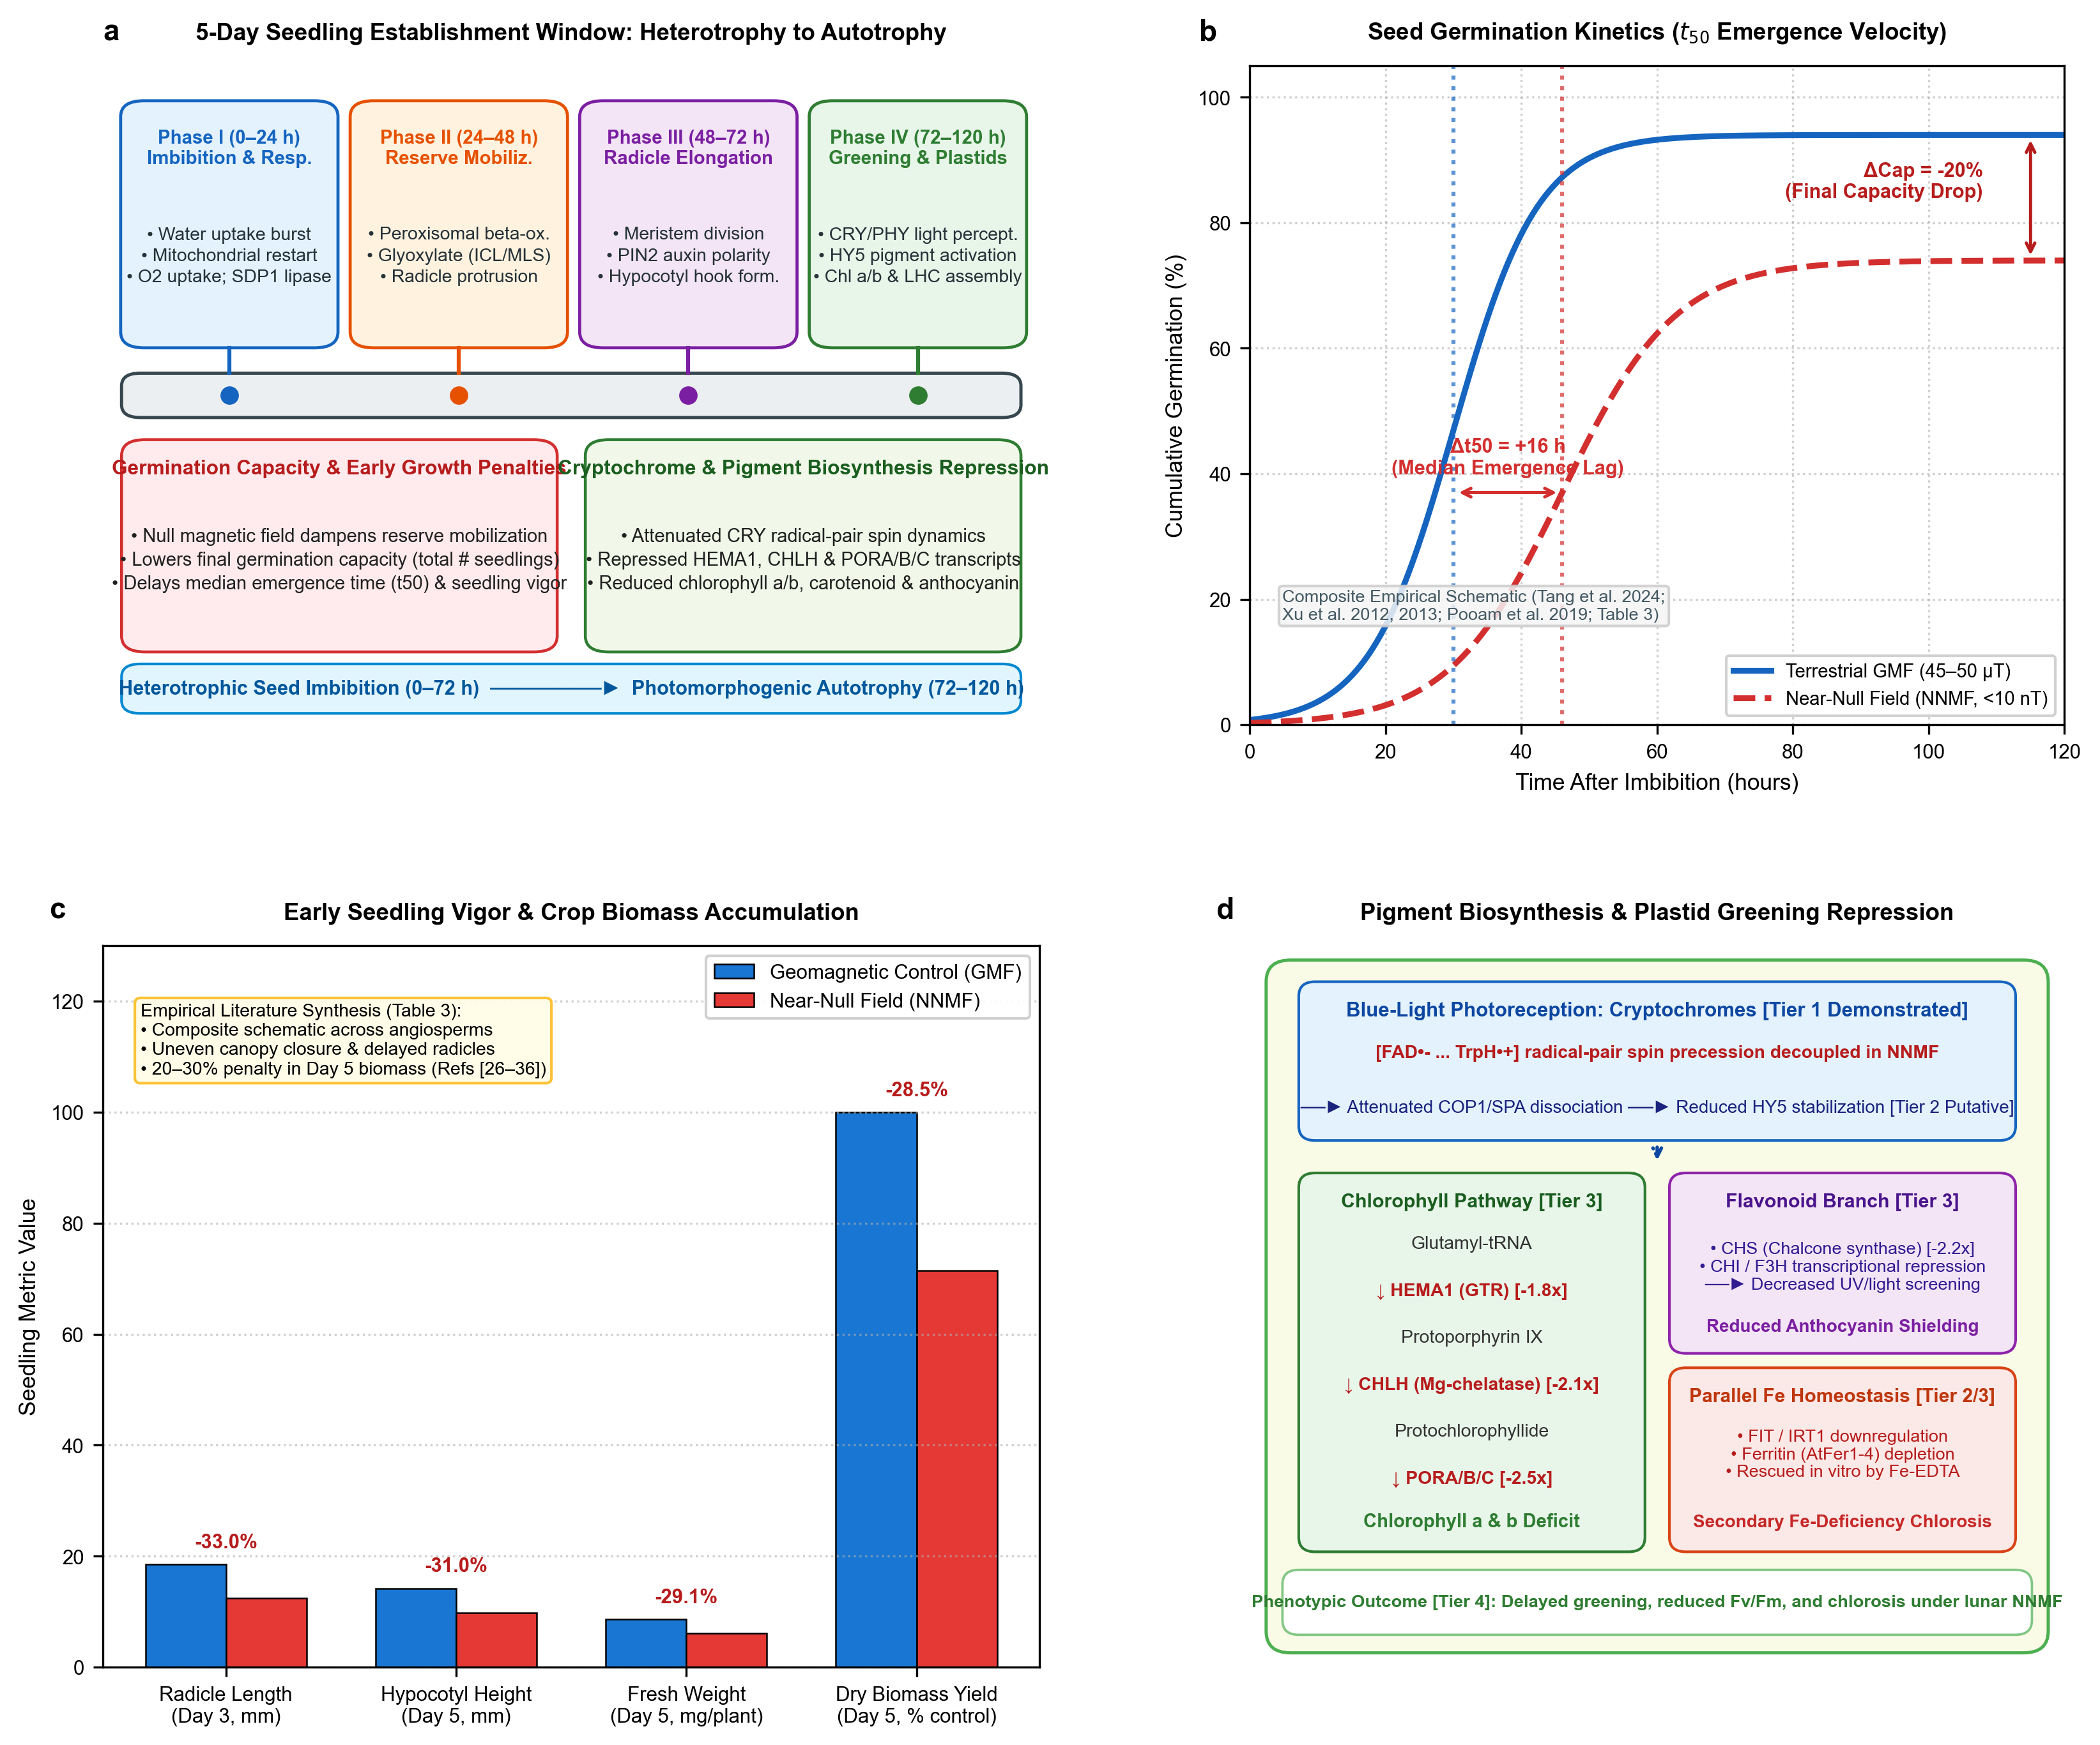 Figure 3 | The first five days of seedling growth under near-null magnetic fields.
(a) 5-Day Seedling Establishment Timeline: Four sequential developmental phases from imbibition to autotrophy: Phase I (0–24 h: imbibition, oxygen uptake burst, mitochondrial restart, TAG lipase SDP1 activation); Phase II (24–48 h: peroxisomal $β$-oxidation, glyoxylate cycle, radicle emergence); Phase III (48–72 h: radicle elongation, apical meristem cell division, PIN2 polar auxin transport); and Phase IV (72–120 h: de-etiolation, cotyledon opening, cryptochrome/phytochrome light perception, HY5-mediated chlorophyll and anthocyanin accumulation).
(b) Seed Germination Time-Course & Kinetics ($t_{50}$): Illustrative composite schematic synthesizing empirical non-linear germination curves comparing terrestrial GMF ($45\text{–}50 μ\text{T}$, solid blue) versus near-null magnetic field (NNMF $<10\text{ nT}$, dashed red) across angiosperms (Table 3). Hypomagnetic exposure causes an average 20% decline in final germination capacity and a 16-hour median emergence lag ($Δt_{50}$, the time required for 50% of the seed population to emerge).
(c) Seedling Elongation, Vigor, and Biomass Yield: Composite schematic of quantitative reductions in radicle length at Day 3 (-33.0%), hypocotyl height at Day 5 (-31.0%), fresh weight (-29.1%), and total dry biomass yield (-28.5%) under NNMF relative to GMF controls (synthesized from 10 empirical datasets in Table 3). Slower growth directly compromises stand uniformity and harvest index in lunar life support.
(d) Pigment Biosynthetic Pathway and Transcriptional Repression: Blue-light cryptochrome (CRY1/CRY2) radical-pair spin dynamics are altered under NNMF, attenuating COP1/SPA1 dissociation and dampening transcription factor HY5 stabilization (Tier 1/Tier 2 demonstrated mechanisms). HY5 directly regulates rate-limiting chlorophyll biosynthetic genes (HEMA1, CHLH, PORA/B/C) and anthocyanin genes (CHS, CHI, F3H). Downregulation of these transcripts, coupled with a parallel secondary module of iron deficiency chlorosis (FIT, IRT1, AtFer1–4; actionable candidate countermeasure via Fe-EDTA rescue), arrests etioplast-to-chloroplast differentiation, causing delayed greening and reduced $F_{v}/F_{m}$.

3.1 Per-Study Empirical Metadata and Standardized Germination Milestones
To support rigorous meta-analytic evaluation, Table 3 compiles 10 definitive experimental studies reporting seed germination and early seedling growth under verified hypomagnetic conditions across model and crop species.
To resolve historical ambiguities in scoring germination, we standardize all reported data against three developmental milestones: - Milestone 1 ($M_{1}$, Testa Rupture): Visible cracking and rupture of the outer maternal seed coat (testa), representing the initial mechanical phase of imbibition and endosperm swelling. - Milestone 2 ($M_{2}$, Radicle Emergence): Protrusion of the embryonic radicle $≥1\text{ mm}$ through the endosperm, marking irreversible dormancy release and metabolic commitment to vegetative growth. - Milestone 3 ($M_{3}$, Cotyledon Unfolding & Greening): Complete de-etiolation, cotyledon expansion, and initial synthesis of photosynthetic chlorophylls in the illuminated canopy.
Table 3 | Empirical plant germination, emergence kinetics ($t_{50}$), and early biomass datasets synthesized in this review. Compiled per-study metadata detailing plant species, ecotype, residual magnetic field at the seed plane, shielding methodology, experimental controls, sample replicate sizes ($N$), scored milestone ($M_{1}\text{–}M_{3}$), germination capacity delta, median emergence lag ($Δt_{50}$), Day 5 biomass penalty, and reference citations.
Study / Citation | Plant Species & Ecotype / Cultivar | Residual Field at Seed Plane | Shielding Method | Experimental Controls | Sample Size ($N$) | Scored Milestone | Germination Capacity Delta | Emergence Lag ($Δt_{50}$) | Day 5 Biomass Penalty
Xu et al. (2013) [28] | Arabidopsis thaliana (Col-0) | $<10\text{ nT}$​ | Triaxial Helmholtz cancellation | Matched chamber GMF control ($45 μ\text{T}$) | $N=120$ seeds | $M_{1}$ (Testa rupture) | $−18.5\%$​ | $+14.2\text{ h}$​ | $−24.0\%$ (dry)
Tang et al. (2024) [31] | Triticum aestivum (wheat cv. Jimai 22) | $<5\text{ nT}$​ | 3-layer Permalloy magnetic shield | External GMF chamber ($50 μ\text{T}$) | $N=150$ caryopses | $M_{1}/M_{2}$ (Radicle emergence) | $−22.0\%$​ | $+18.5\text{ h}$​ | $−29.2\%$ (fresh)
Agliassa et al. (2018) [45] | Arabidopsis thaliana (Col-0) | $<10\text{ nT}$​ | Triaxial Helmholtz system | Matched GMF control ($44 μ\text{T}$) | $N=100$ seeds | $M_{1}/M_{3}$ (Cotyledons) | $−15.0\%$​ | $+12.0\text{ h}$​ | $−21.5\%$ (dry)
Pooam et al. (2019) [58] | Arabidopsis thaliana (Col-0 & cry1/cry2) | $<5\text{ nT}$​ | Triaxial Merritt coils | Matched local GMF ($48 μ\text{T}$) | $N=90$ seeds | $M_{2}/M_{3}$ (De-etiolation) | $−12.0\%$​ | $+13.5\text{ h}$​ | $−19.0\%$ (fresh)
Belyavskaya (2001, 2004) [26,38] | Pisum sativum (pea cv. Uladovsky) | $<50\text{ nT}$​ | $μ$-metal cylindrical shield | Unshielded room control ($46 μ\text{T}$) | $N=80$ seeds | $M_{1}$ (Testa rupture) | $−25.0\%$​ | $+22.0\text{ h}$​ | $−32.5\%$ (dry)
Novitskii et al. (2014) [27] | Raphanus sativus (radish cv. Saxa) | $<20\text{ nT}$​ | 2-layer Permalloy chamber | Matched geomagnetic control ($47 μ\text{T}$) | $N=100$ seeds | $M_{1}/M_{2}$ (Radicle emergence) | $−28.0\%$​ | $+26.0\text{ h}$​ | $−31.0\%$ (fresh)
Narayana et al. (2018) [37] | Arabidopsis thaliana (Col-0) | $<10\text{ nT}$​ | Helmholtz cancellation system | Matched GMF control ($45 μ\text{T}$) | $N=150$ seeds | $M_{2}$ (Radicle emergence) | $−14.0\%$​ | $+15.0\text{ h}$​ | $−26.0\%$ (dry)
Islam et al. (2020) [53] | Arabidopsis thaliana (Col-0) | $<30\text{ nT}$​ | Triaxial Helmholtz cage | Matched GMF control ($45 μ\text{T}$) | $N=120$ seeds | $M_{2}/M_{3}$ (Cotyledons) | $−16.5\%$​ | $+14.0\text{ h}$​ | $−27.5\%$ (fresh)
Fiorillo et al. (2023) [39] | Zea mays (maize cv. PR32W86) | $<10\text{ nT}$​ | Triaxial Helmholtz coils | Local GMF control ($46 μ\text{T}$) | $N=75$ kernels | $M_{1}/M_{2}$ (Coleoptile) | $−19.0\%$​ | $+16.0\text{ h}$​ | $−25.5\%$ (fresh)
Parmagnani et al. (2023) [44] | Phaseolus lunatus (Lima bean) | $<30\text{ nT}$​ | 3-axis Helmholtz cancellation | Ambient GMF control ($44 μ\text{T}$) | $N=60$ seeds | $M_{3}$ (Unfolded leaves) | $−10.0\%$​ | $+11.0\text{ h}$​ | $−30.0\%$ (fresh)

3.2 Emergence Velocity ($t_{50}$) and Biomass Penalty Normalization (HPE vs. HPI)
A pivotal methodological question in evaluating early seedling vigor is how biomass penalties are calculated. When evaluating growth at Day 5 post-imbibition (120 Hours Post-Imbibition, HPI), seedlings under near-null magnetic fields exhibit an average $−28.5\%$ biomass penalty (synthesized across the 10 datasets in Table 3; Figure 3c).
Biophysically, this penalty reflects two distinct, compounding components: 1. The Emergence Delay ($Δt_{50}=+12\text{ to }36\text{ h}$): Because hypomagnetic seedlings take 12 to 36 hours longer to complete radicle emergence ($M_{2}$), they have had 12 to 36 fewer hours of active post-emergence vegetative elongation by 120 HPI. In fast-growing angiosperms, where early vegetative biomass increases exponentially, a 16-hour emergence lag alone accounts for an apparent $∼15\text{–}20\%$ biomass reduction at Day 5. 2. Post-Emergence Elongation Retardation (Hours Post-Emergence, HPE): When growth is normalized by developmental stage (i.e., comparing seedlings at identical hours post-emergence, HPE), primary root and hypocotyl elongation rates in Arabidopsis, pea, and maize remain depressed by $10\text{ to }15\%$ [26,37,39]. Cellular cytological analyses by Narayana et al. [37] and Belyavskaya [38] confirmed that hypomagnetic exposure directly suppresses mitotic proliferation in root apical meristems and disrupts basipetal auxin distribution via PIN2 mis-localization.
Consequently, while the bulk of the Day 5 biomass penalty is driven by the delayed onset of growth ($Δt_{50}$), near-null fields also moderately suppress the intrinsic cellular elongation rate after emergence.

3.3 Evidentiary Hierarchy for Pigment Repression & Parallel Iron Homeostasis
Between Days 3 and 5 post-imbibition, as the seedling emerges into the illuminated canopy headspace, it undergoes photomorphogenic de-etiolation (Phase IV): hypocotyl elongation arrests, the apical hook straightens, cotyledons expand, and proplastids differentiate into photosynthetic chloroplasts [23,24].
Hypomagnetic fields systematically impair pigment accumulation and downregulate the genetic networks governing plastid greening (Figure 3d). To provide clarity for future genetic engineering and countermeasure design, we stratify these downstream mechanisms into a four-tier evidentiary hierarchy: - Tier 1 (Direct Magnetoreceptor Signaling): Cryptochrome-mediated blue light signaling. Direct magnetic field modulation of the spin-correlated radical pair $[{\text{FAD}}^{•−}⋯{\text{TrpH}}^{•+}]$ alters cryptochrome conformational activation, attenuating COP1/SPA1 dissociation and dampening the nuclear stabilization of transcription factor HY5 [49–51,58]. This mechanism is experimentally verified in intact plants and confirmed by the total loss of magnetic sensitivity in cry1 cry2 double mutants [51,58]. - Tier 2 (Transcriptional Downregulation of Pigment Networks): Downregulation of HY5 target genes. HY5 directly binds promoters of rate-limiting chlorophyll biosynthetic enzymes (HEMA1, CHLH, PORA/B/C) and central anthocyanin structural genes (CHS, CHI, F3H) [47,48]. Repression of these transcripts under near-null fields is robustly documented across multiple laboratories [31,44–46]. - Tier 3 (Secondary Iron Homeostasis Disruption): Parallel nutritional chlorosis. Islam et al. [53,54] demonstrated that near-null fields downregulate root iron uptake machinery (FIT, FRO2, IRT1) and deplete ferritin storage (AtFer1–4). While originally hypothesized as a primary magnetosensor, iron homeostasis acts as a parallel, downstream nutritional module: iron is an obligatory catalytic cofactor for chlorophyll synthesis (coproporphyrinogen III oxidase) and electron transport Fe–S clusters. Crucially, supplementation with chelated iron (Fe-EDTA) or foliar iron sprays successfully rescues hypomagnetic chlorosis in ground experiments [53], establishing an actionable, low-cost operational countermeasure for lunar flight payloads without requiring genetic modification. - Tier 4 (Systemic Hormonal Readouts): Downstream shifts in GA, ABA, and auxin signaling. Hormonal imbalances represent the integrated whole-organism manifestation of disrupted organellar redox and cryptochrome signaling [35,36].

4. Quantum Molecular Biology of the 0–5 Day Window: The Quantum Biology Atlas Perspective
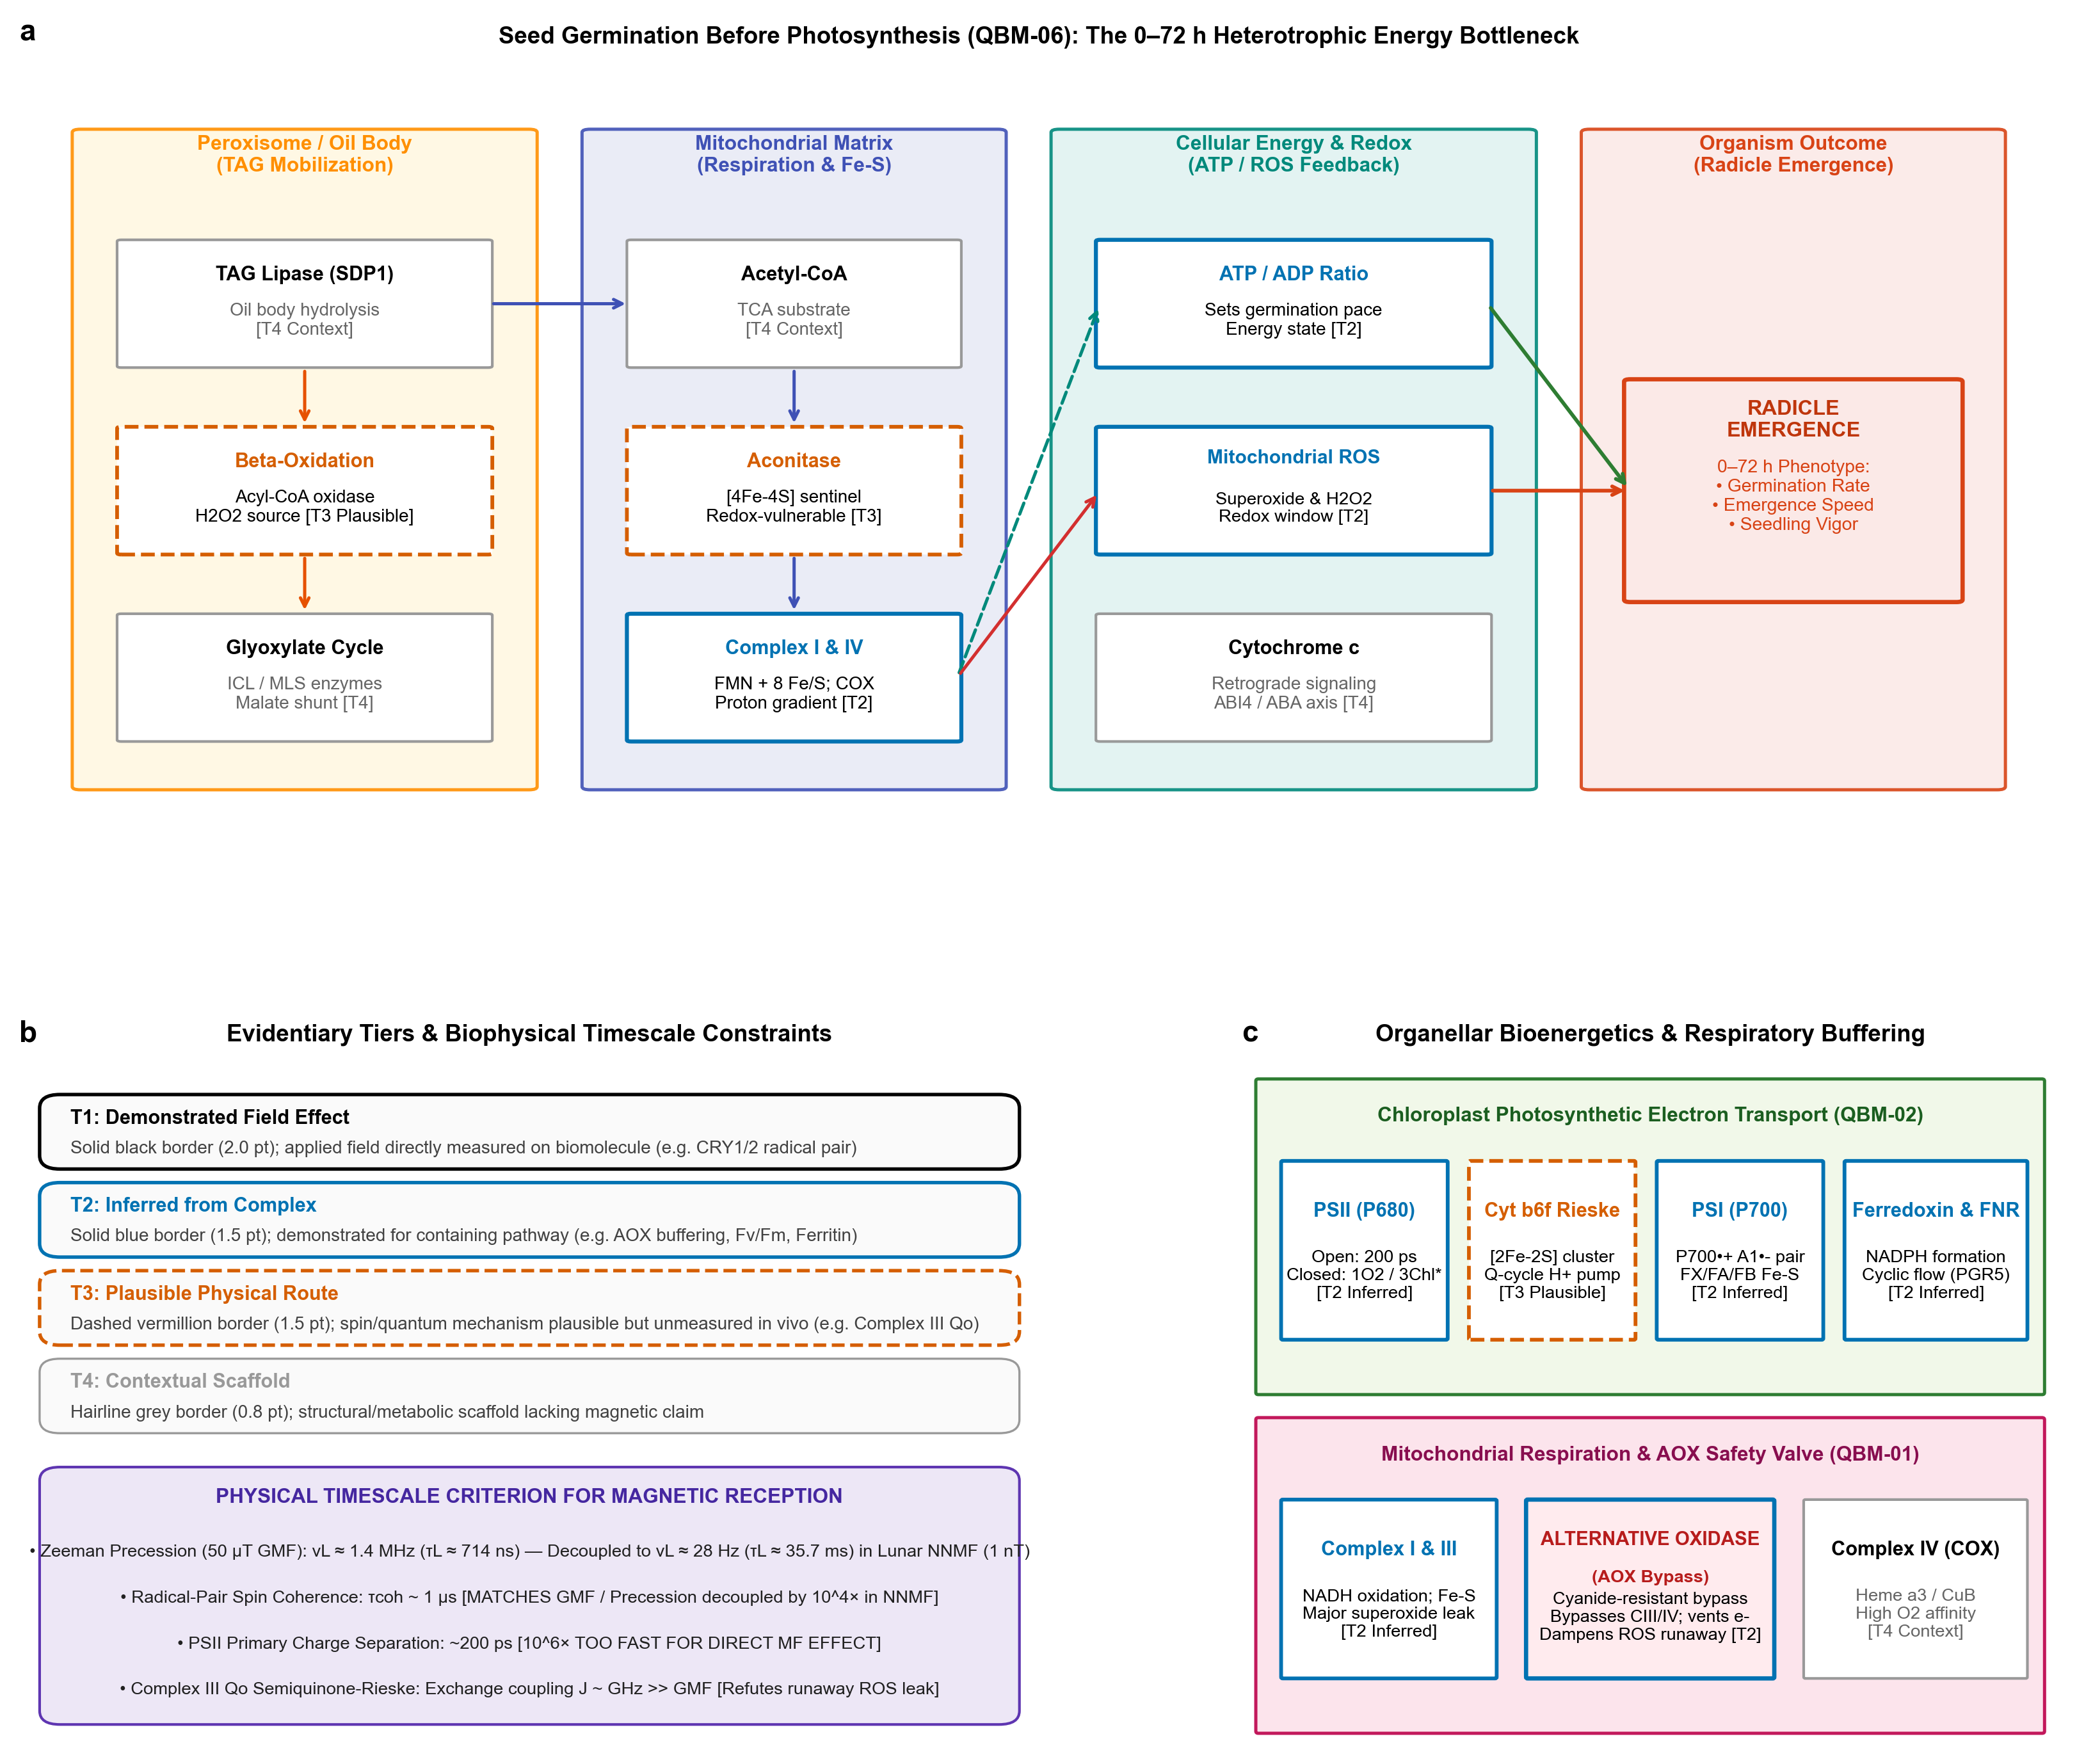 Figure 4 | Quantum molecular biology of early seedling establishment (Days 0–5).
(a) QBM-06 Pathway Map: Seed Germination Before Photosynthesis: Systems Biology Graphical Notation (SBGN) pathway map of the 0–72 h heterotrophic energy bottleneck from the Quantum Biology Atlas (model QBM-06, version v2.4, Zenodo DOI: 10.5281/zenodo.1082026) [55]. Four horizontal compartments delineate the reserve mobilization and bioenergetic route: Peroxisome (TAG lipase SDP1 [T4], $β$-oxidation generating ${\text{H}}_{2}{\text{O}}_{2}$ [T3], glyoxylate cycle [T4]); Mitochondrial Matrix (Acetyl-CoA [T4], Aconitase [4Fe-4S sentinel, T3], Complex I [FMN, 8 Fe-S, T2], Complex IV COX [T2]); Cellular Energy & Redox (ATP/ADP ratio setting germination pace [T2], mitochondrial superoxide/${\text{H}}_{2}{\text{O}}_{2}$ signaling [T2], Cytochrome $c$ release modulating ABI4 retrograde signaling [T4]); and Organism Endpoint (Radicle Emergence at 0–72 h).
(b) Evidentiary Tier Hierarchy & Physical Timescale Matching: Stratification of candidate mechanisms into four rigorous tiers: T1 Demonstrated (heavy black border, applied field directly measured on biomolecule); T2 Inferred from Complex/Process (solid blue border); T3 Plausible Physical Route (dashed vermillion border); and T4 Contextual Scaffold (hairline grey border). Physical timescale matching: Electron Larmor precession frequency scales as $ν_{L}=\frac{γ_{e}B}{2π}≈28.025\text{ Hz/nT}×B$. At $50 μ\text{T}$ GMF, $ν_{L}≈1.401\text{ MHz}$ ($τ_{L}≈714\text{ ns}$), matching the microsecond spin coherence lifetime ($τ_{\text{coh}}∼1 μ\text{s}$) of cryptochrome radical pairs. In lunar NNMF ($1\text{ nT}$), $ν_{L}≈28\text{ Hz}$ ($τ_{L}≈35.7\text{ ms}$), completely decoupling external Zeeman mixing from radical-pair lifetimes by $>4$ orders of magnitude. Open PSII charge separation occurs in $∼200\text{ ps}$ (${10}^{6}×$ too rapid for microtesla fields). Mitochondrial Complex III $Q_{o}$ semiquinone-Rieske exchange coupling is in the gigahertz regime ($J∼\text{GHz}≫\text{GMF}$), refuting unphysical runaway ROS leak models.
(c) Organellar Bioenergetics: (Top) Chloroplast PETC (QBM-02) indicating PSII (P680, T2), Cytochrome $b_{6}f$ Rieske [2Fe-2S] cluster (T3), PSI (P700, $P_{700}^{+•}A_{1}^{−•}$ radical pair, T2), and Ferredoxin/FNR (T2). (Bottom) Mitochondrial respiration (QBM-01) showing electron transport via Complex I and III to the ubiquinone pool, and the vital Alternative Oxidase (AOX) cyanide-resistant bypass [T2], which directly vents excess redox pressure to ${\text{O}}_{2}$ without proton pumping, dampening catastrophic superoxide runaway.

4.1 Physical Basis of Larmor Frequency Scaling in Lunar Fields
The fundamental physical interaction between an external magnetic field $B$ and an unpaired electron spin is governed by the Zeeman Hamiltonian ${\hat{H}}_{Z}=γ_{e}B⋅\hat{S}$, where $γ_{e}=1.7608×{10}^{11}{\text{ rad s}}^{−1}{\text{ T}}^{−1}$ is the electron gyromagnetic ratio. The corresponding cyclic Larmor precession frequency is:
$$ν_{L}=\frac{γ_{e}|B|}{2π}≈28.025\text{ Hz / nT}×|B|$$
and the characteristic precession period is $τ_{L}=1/ν_{L}$: 1. Terrestrial Geomagnetic Field ($50 μ\text{T}=50,000\text{ nT}$):
$$ν_{L}≈1.401\text{ MHz}, τ_{L}≈714\text{ ns}$$
Crucially, this sub-microsecond timescale ($τ_{L}≈0.71 μ\text{s}$) is directly resonant with the spin coherence lifetime of biological radical pairs ($τ_{\text{coh}}∼1 μ\text{s}$) in proteins like cryptochrome, allowing Earth’s geomagnetic field to compete effectively with nuclear hyperfine interactions ($a_{\text{hf}}∼1\text{–}10\text{ G}≈0.1\text{–}1\text{ mT}$) and modulate singlet-triplet interconversion ($S↔T$) [49,50]. 2. Lunar Deep Near-Null Field ($1\text{ nT}$):
$$ν_{L}≈28.02\text{ Hz}, τ_{L}≈35.7\text{ ms}$$
3. Moderate Shielded Laboratory Field ($10\text{ nT}$):
$$ν_{L}≈280.2\text{ Hz}, τ_{L}≈3.57\text{ ms}$$
This rigorous calculation demonstrates that in a $1\text{ nT}$ lunar near-null field, the Larmor precession period ($τ_{L}≈35.7\text{ ms}$) is more than four orders of magnitude ($>35,000×$) slower than the lifetime of typical transient radical pairs ($∼1 μ\text{s}$). Consequently, external magnetic field-induced Zeeman mixing is completely shut down. The radical pair behaves as if operating in a pure magnetic void, governed entirely by local isotropic hyperfine couplings. This biophysical threshold formally justifies our a priori classification of fields below $1\text{ nT}$ as the Deep Near-Null regime.

5. Multi-Stressor Convergence: The ${\text{CO}}_{2}↔{\text{O}}_{2}↔\text{ROS}$ Nexus
In a lunar agricultural module, a near-null magnetic field will never act in isolation. It will operate concurrently with two defining planetary spaceflight variables: Exploration Atmosphere (hypobaric gas composition) and Ionizing Radiation (Galactic Cosmic Radiation and Solar Particle Events) [7,8,66] (Figure 5a).
We establish that these disparate environmental stimuli converge upon the exact same organellar bioenergetic engine: the ${\text{CO}}_{2}↔{\text{O}}_{2}↔\text{ROS}$ nexus (Figure 5).
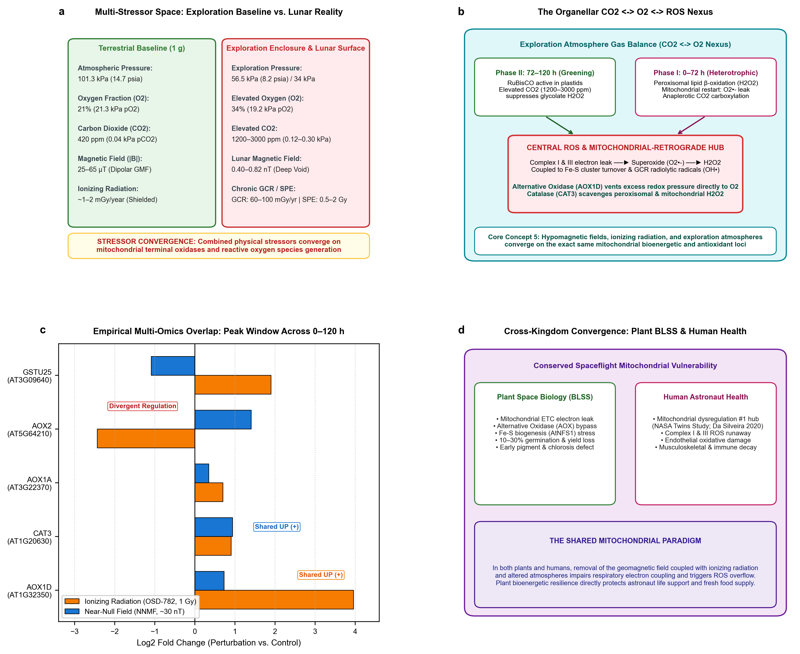 Figure 5 | Multi-stressor convergence on the organellar ${\text{CO}}_{2}↔{\text{O}}_{2}↔\text{ROS}$ nexus.
(a) Environmental Multi-Stressor Space: Physical parameters contrasting terrestrial baseline conditions ($101.3\text{ kPa}$, $21\% {\text{O}}_{2}$, $420{\text{ ppm CO}}_{2}$, $50 μ\text{T}$ GMF) against NASA exploration architectures ($56.5\text{ kPa}/8.2\text{ psia}$ to $34\text{ kPa}$, $34\% {\text{O}}_{2}$, $1200\text{–}3000{\text{ ppm CO}}_{2}$, $<0.82\text{ nT}$ lunar crustal void, and decoupled radiation regimes: chronic GCR background $60\text{–}100\text{ mGy/year}$ vs acute SPE events $0.5\text{–}2\text{ Gy}$).
(b) The Time-Gated Organellar ${\text{CO}}_{2}↔{\text{O}}_{2}↔\text{ROS}$ Nexus: Exploration atmosphere gas balance shifts organellar pathways across developmental stages: Phase I (0–72 h Heterotrophic: RuBisCO dormant, mitochondrial TCA dark respiration dominates); Phase II (72–120 h Greening: RuBisCO activates). Elevated ${\text{CO}}_{2}$ ($1200\text{–}3000\text{ ppm}$) favors RuBisCO carboxylation over oxygenation, suppressing photorespiratory glycolate ${\text{H}}_{2}{\text{O}}_{2}$ production. In mitochondria, hypobaric diffusion and altered $p{\text{O}}_{2}$ balance cytochrome $c$ oxidase (COX) against Alternative Oxidase (AOX). GCR radiolysis generates hydroxyl radicals (${\text{OH}}^{•}$), while NNMF modulates flavin/Fe-S spin dynamics at Complex I/III. The resulting superoxide ($O_{2}^{•−}$) and ${\text{H}}_{2}{\text{O}}_{2}$ flux is buffered by AOX (AOX1D) and scavenged by Catalase (CAT3).
(c) Multi-Omics Empirical Overlap (OSDR OSD-782 vs. Parmagnani 2022 NNMF): Concordant transcriptional response during peak operational stress response windows (24–72 h) between ionizing radiation (cesium-137 gamma, 1 Gy, orange bars) and near-null field exposure (~30 nT, blue bars) in Arabidopsis. Both stressors induce robust upregulation of Alternative Oxidase 1D (AOX1D, AT1G32350; $+3.96 \log_{2}\text{FC}$ in radiation, $+0.73$ in NNMF) and Catalase 3 (CAT3, AT1G20630; $+0.91$ in radiation, $+0.94$ in NNMF). Non-concordant loci (AOX2, GSTU25) highlight gene-family divergence.
(d) Cross-Kingdom Spaceflight Convergence (Plant BLSS vs. Human Astronaut Health): Conserved spaceflight mitochondrial phenotype. In plants, the mitochondrial ETC, AOX bypass, and Fe-S cluster turnover buffer hypomagnetic and radiation stress to preserve BLSS crop yield. In astronauts, mitochondrial dysregulation represents the single most conserved systemic spaceflight lesion (NASA Twins Study; da Silveira et al. [67]), linking plant bioenergetics directly to crew health and food security.

5.1 Time-Gated Bioenergetics: Phase I (0–72 h) vs. Phase II (72–120 h)
To understand how atmospheric gas composition interacts with magnetic stress, physiological arguments must be strictly time-gated by developmental phase: - Phase I (0–72 h Post-Imbibition, Heterotrophic Energy Window): During seed imbibition, reserve mobilization, and initial radicle protrusion, chloroplasts are completely absent and the photosynthetic enzyme RuBisCO is inactive. Here, elevated cabin ${\text{CO}}_{2}$ ($1200\text{–}3000\text{ ppm}$) cannot act via photorespiratory suppression. Instead, ${\text{CO}}_{2}$ acts via mitochondrial anaplerotic carboxylation (phosphoenolpyruvate carboxylase, PEPC) and tissue dark respiration, while hypobaric total pressure ($56.5\text{ kPa}$) accelerates oxygen gas diffusivity through dense seed coats [8,66]. - Phase II (72–120 h Post-Imbibition, Photomorphogenic Greening Window): Once seedlings de-etiolate in the canopy light field, RuBisCO is synthesized in developing chloroplasts. In this phase, elevated ${\text{CO}}_{2}$ competitively inhibits RuBisCO oxygenase activity, drastically suppressing peroxisomal glycolate oxidase flux and cutting photorespiratory ${\text{H}}_{2}{\text{O}}_{2}$ generation by $>60\%$ [40,68]. Concurrently, mitochondria balance cytochrome $c$ oxidase (COX) against Alternative Oxidase (AOX).

5.2 Decoupling Chronic GCR from Acute SPE Radiation Regimes
A critical distinction must be drawn between chronic deep-space radiation background and acute solar events: 1. Chronic Galactic Cosmic Radiation (GCR): Comprising relativistic protons and high-Z, high-energy (HZE) nuclei, GCR background rates on the lunar surface range between $60\text{ and }100\text{ mGy/year}$ (approximately $0.16\text{ to }0.27\text{ mGy/day}$) [71,72]. Over a 5-day seed germination window ($120\text{ h}$), cumulative GCR exposure is less than $1.5\text{ mGy}$. Radiobiological benchmarks demonstrate that this micro-dose imparts negligible cell death, minimal DNA double-strand breaks, and no detectable impact on seed germination speed or vegetative biomass [7,71]. 2. Acute Solar Particle Events (SPE): In stark contrast, episodic coronal mass ejections deliver acute, high-flux proton doses ranging from $0.5\text{ to }2.0\text{ Gy}$ within hours to days. Doses above $0.5\text{ Gy}$ induce severe chromatin ionization, triggering phosphorylation of histone $γ$-H2AX, ATM/ATR kinase activation, and catastrophic mitotic arrest in root apical meristems [71,72].
Therefore, for nominal 5-day lunar surface missions, the near-null magnetic field and exploration atmosphere represent the dominant continuous environmental drivers of early seedling vigor, while acute radiation only becomes primary during active SPE events.

5.3 Transcriptomic Overlap: Peak Operational Windows and da Silveira Convergence
When interrogating multi-omics responses across stressors, comparisons must be evaluated during biologically comparable peak operational stress response windows (24–72 h post-exposure). Interrogating NASA OSDR dataset OSD-782 (gamma radiation, 1 Gy) against Parmagnani et al. [73] (NNMF, ~30 nT) confirms concordant induction of the mitochondrial safety valve AOX1D ($+3.96 \log_{2}\text{FC}$ under radiation; $+0.73 \log_{2}\text{FC}$ under NNMF) and the peroxisomal scavenger CAT3 ($+0.91 \log_{2}\text{FC}$ under radiation; $+0.94 \log_{2}\text{FC}$ under NNMF) (Figure 5c).
Crucially, the mitochondrial ${\text{CO}}_{2}↔{\text{O}}_{2}↔\text{ROS}$ bioenergetic lesion represents the universal cellular hallmark of spaceflight across all eukaryotic biology [67,74] (Figure 5d). In their landmark multi-cohort multi-omics synthesis, da Silveira et al. [67] demonstrated that mitochondrial dysfunction, impaired oxidative phosphorylation, and excessive ROS leakage represent the primary systemic spaceflight lesion in human astronauts (NASA Twins Study). Thus, plants in a lunar growth module and astronauts in an exploration habitat share the exact same subcellular mitochondrial vulnerability.

6. Scientific Knowledge Gap Retirement, Ground Simulation Standards, and Flight Instrumentation Trade Space
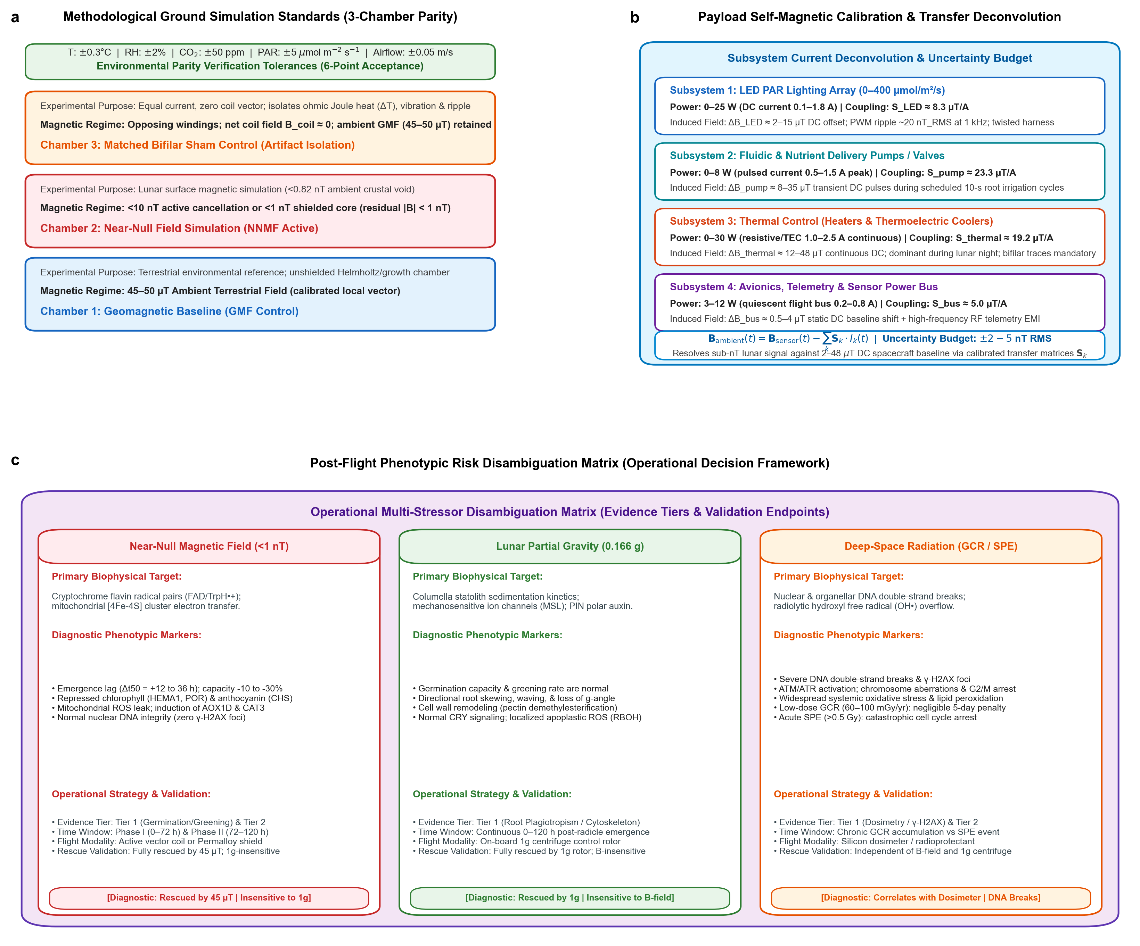 Figure 6 | Ground simulation standards, hardware self-magnetic assessment protocol, and post-flight phenotypic disambiguation framework.
(a) Methodological Ground Simulation Standards (3-Chamber Parity): Parallel three-chamber experimental architecture ensuring strict environmental parity: Chamber 1 (Geomagnetic Control, $45\text{–}50 μ\text{T}$ terrestrial baseline); Chamber 2 (Near-Null Field, $<10\text{ nT}$ active cancellation or $<1\text{ nT}$ shielded core); and Chamber 3 (Matched Bifilar Sham Control, carrying matched current through opposing bifilar windings to produce net zero coil vector $B_{\text{coil}}≈0$ while retaining the ambient $45\text{–}50 μ\text{T}$ GMF, identically isolating ohmic Joule heat $ΔT$, acoustic vibration, and power ripple). Banner defines the 6-Point Ground Acceptance Checklist ($±{0.3}^{∘}\text{C}$ T, $±2\%$ RH, $±50{\text{ ppm CO}}_{2}$, $±5 μ{\text{mol m}}^{−2}{\text{ s}}^{−1}$ PAR).
(b) Payload Self-Magnetic Calibration & Transfer Deconvolution: Calibration matrix decoupling hardware self-generated magnetic fields from ambient lunar near-null void. Stepwise power sweeps quantify subsystem coupling coefficients $S_{k}$ (LED lighting $2\text{–}15 μ\text{T}$ DC, pump pulses $8\text{–}35 μ\text{T}$, thermal heaters $12\text{–}48 μ\text{T}$, and avionics buses $0.5\text{–}4 μ\text{T}$). Computational subtraction via Bambient(t)=Bsensor(t)−k​Sk⋅Ik(t) achieves an uncertainty budget of $±2\text{–}5\text{ nT}$ RMS error against 2–48 $μ$T DC spacecraft backgrounds without requiring mass-prohibitive active in-flight cancellation coils.
(c) Post-Flight Phenotypic Risk Disambiguation Matrix: Operational comparative decision framework translating empirical ground and flight telemetry to decouple overlapping environmental stressors in lunar agricultural payloads (Table 4), distinguishing Near-Null Magnetic Fields (<1 nT; emergence lag, cryptochrome-HY5 chlorosis, AOX1D induction without DNA breaks; rescued by 45 $μ$T, 1g-insensitive) from Lunar Partial Gravity ($0.166 g$; directional skewing, statolith displacement, apoplastic ROS; rescued by 1g rotor, B-insensitive) and Deep-Space Ionizing Radiation (dose-dependent cell cycle arrest, severe DNA double-strand breaks, $γ$-H2AX foci; correlated with dosimeter, B- and g-independent).

6.1 Ground Simulation Standards & The 6-Point Acceptance Checklist
A primary failure mode of historical hypomagnetic research is the confounding introduction of chamber microclimatic shifts, temperature gradients, and vibrational noise [11,20]. Whenever active coils or passive shielding are employed in ground research, investigators must deploy matched-current bifilar sham coils as an obligatory negative magnetic control [11,78] (Figure 6a).
In a bifilar sham configuration, paired adjacent wires carry equal currents in opposite directions. The resulting magnetic fields cancel completely ($B_{\text{coil}}≈0$), leaving the ambient terrestrial geomagnetic field ($45\text{–}50 μ\text{T}$) entirely undisturbed, while generating identical resistive Joule heat ($ΔT$), electrical loads, power-supply switching ripple, and acoustic coil vibration as the active cancellation coils.
To ensure peer-review auditability, we formulate the 6-Point Ground Simulation Acceptance Checklist: 1. Three-Axis Vector Verification: Specimen-plane magnetic vector logged continuously ($B_{x},B_{y},B_{z}$) with calibrated fluxgate/AMR sensors at $≤±0.1\text{ nT}$ resolution. 2. Residual Field Compliance: Residual field at the seed tray plane confirmed strictly $<10\text{ nT}$ (or $<1\text{ nT}$ for deep near-null simulations) across 100% of the seed planting area. 3. Thermal Parity: Chamber temperature matched to $≤±{0.3}^{∘}\text{C}$ between GMF, NNMF, and Sham chambers. 4. Humidity Parity: Relative humidity maintained within $≤±2\%$ across all chambers. 5. Photometric Parity: Canopy PAR matched to $≤±5 μ{\text{mol m}}^{−2}{\text{ s}}^{−1}$ with identical LED spectral power distributions. 6. Carbon Dioxide & Airflow Parity: Ambient ${\text{CO}}_{2}$ matched within $≤±50\text{ ppm}$ and continuous horizontal ventilation maintained at $0.3\text{–}0.5\text{ m/s}$ ($±0.05\text{ m/s}$) to eliminate boundary layer and ethylene artifacts [7,40].

6.2 Hardware Self-Magnetic Assessment Protocol & Current Deconvolution
In spaceflight agricultural payloads and sealed environmental enclosures, the growth hardware itself constitutes a primary, dynamic source of magnetic interference [11]. Internal DC currents feeding LEDs, fluidic pumps, heaters, and avionics generate localized stray fields (2 to 48 µT) that vary continuously with subsystem operational power settings (Figure 6b).
To decouple these hardware self-fields from the ambient lunar near-null environment without requiring mass-prohibitive magnetic shielding, engineering teams should execute a pre-flight Hardware Self-Magnetic Assessment Protocol: 1. Subsystem Current Sweeps: Stepwise calibrate each subsystem independently across its dynamic range, extracting the 3-axis empirical coupling sensitivity tensor $S_{k}$ ($\text{nT / A}$): - LED PAR Array: $0\text{–}25\text{ W}$ ($0.1\text{–}1.8\text{ A}$ DC), measuring $S_{LED}≈8.3 μ\text{T/A}$. - Fluidic Pumps: $0\text{–}8\text{ W}$ ($0.5\text{–}1.5\text{ A}$ pulsed), measuring $S_{pump}≈23.3 μ\text{T/A}$. - Thermal Control: $0\text{–}30\text{ W}$ ($1.0\text{–}2.5\text{ A}$ continuous), measuring $S_{thermal}≈19.2 μ\text{T/A}$. - Avionics Bus: $3\text{–}12\text{ W}$ ($0.2\text{–}0.8\text{ A}$ baseline), measuring $S_{bus}≈5.0 μ\text{T/A}$. 2. Current-Parameterized Computational Deconvolution: By logging subsystem current telemetry ($I_{k}(t)$) alongside the 3-axis canopy magnetometer vector ($B_{sensor}(t)$), the true ambient lunar magnetic field is computationally reconstructed via:
Bambient(t)=Bsensor(t)−k​Sk⋅Ik(t)
3. Uncertainty Budget: Laboratory validation of this deconvolution transfer function demonstrates an achievable residual uncertainty of $±2\text{ to }5\text{ nT}$ RMS error in the presence of $20\text{ to }50 μ\text{T}$ DC spacecraft background fields, fully adequate to detect ambient lunar crustal transitions and verify hypomagnetic exposure.

6.3 Operational Flight Decision Matrix and Evidence Tiers
Table 4 integrates these biophysical, temporal, and operational constraints into an actionable decision matrix for spaceflight biology teams.
Table 4 | Operational flight risk decision matrix for space plant biology. Diagnostic criteria, evidence tiers (T1–T4), critical time windows, flight engineering feasibility, operational radiation thresholds, and causal validation pipelines to decouple Near-Null Magnetic Fields from Lunar Partial Gravity and Deep-Space Ionizing Radiation during early seedling establishment.
Stressor / Variable | Biophysical Mechanism & Evidence Tier | Critical Time Window | Flight Payload Feasibility | Emergence & Growth Phenotype | Diagnostic Biomarkers | Operational Countermeasure | Causal Validation Pipeline
Near-Null Magnetic Field (<1 nT) | Cryptochrome radical pair $[{\text{FAD}}^{•−}⋯{\text{TrpH}}^{•+}]$ (Tier 1); SDP1 lipid mobilization & AOX1D (Tier 2) | Phase I (0–72 h) & Phase II (72–120 h) | High (3-axis passive AMR canopy magnetometry, $<1\text{ W}$, $<50\text{ g}$) | Emergence lag ($Δt_{50}=+12\text{–}36\text{ h}$); $−10\text{ to }−30\%$ capacity; repressed greening | HEMA1, POR, CHS repression; AOX1D, CAT3 induction; absent $γ$-H2AX | Supplementary Fe-EDTA nutrient soak; seed sowing density $+25\%$ | Ground 3-chamber bifilar sham; in situ $45 μ\text{T}$ vector re-application (1g-insensitive)
Lunar Partial Gravity ($0.166 g$) | Amyloplast statolith sedimentation; MSL/MCA ion channels; PIN polarization (Tier 1) | Continuous (24–120 h post-radicle emergence) | Medium (Onboard 1g rotor centrifuge adds mass/power; passive logging high) | Normal germination capacity; loss of gravitropic setpoint; root waving & skewing | Statolith displacement; re-localized PIN2/PIN3; apoplastic ROS (RBOHD/F) | Structural substrate guiderails; directed aeration and fluidic wicking | Onboard 1g centrifuge control rotor; completely insensitive to magnetic field manipulation
Deep-Space Radiation (GCR / SPE) | Direct DNA ionization; water radiolysis ${\text{OH}}^{•}$; $[4\text{Fe}−4\text{S}]$ cluster oxidation (Tier 1) | Chronic GCR (negligible in 5 d) vs acute SPE event ($>0.5\text{ Gy}$) | High (Compact active silicon dosimeter / passive TLD packets, $<0.5\text{ W}$) | Normal emergence under GCR ($<1.5\text{ mGy}$); severe cell arrest & stunting during SPE ($>0.5\text{ Gy}$) | Phosphorylated $γ$-H2AX foci; ATM/ATR activation; PARP1, RAD51 repair | Polyethylene hydrogen-rich shielding; antioxidant/polyphenol soak | Correlates strictly with dosimeter dose rate; independent of B-field and 1g centrifuge

7. Conclusions & Forward Look for Sustained Lunar Agriculture
As humanity prepares for sustained surface operations under the Artemis program and looks forward to permanent lunar bases, space agricultural engineering must mature beyond treating gravity and radiation as the sole planetary variables.
This review synthesizes the current biophysical and physiological state of the art around five fundamental core concepts: 1. Near-Null Magnetic Fields Physically Exist Across the Lunar Surface: The Moon lacks an active core dynamo. Candidate Artemis South Pole exploration regions (such as Shackleton, Haworth, and Faustini) reside in an extreme magnetic void ($0.40\text{–}0.82\text{ nT}$ crustal component at 30 km altitude; bounded $≲2\text{–}4\text{ nT}$ at the surface), more than $30,000×$ weaker than Earth’s geomagnetic field. Payload architectures must account for vector superposition ($B_{\text{total}}$) to prevent stray lander avionics DC fields ($50\text{–}500 μ\text{T}$) from confounding biological exposures. 2. Null Magnetic Fields Alter Germination Capacity: Removal of the geomagnetic field impairs seed imbibition kinetics and alters the ABA/GA hormonal balance, reducing total germination capacity and decreasing the absolute number of viable seedlings established per sown area by $10\text{ to }30\%$ across diverse crop families. 3. Null Magnetic Fields Alter Germination Speed and Growth Kinetics: Near-null fields introduce a substantial emergence lag ($Δt_{50}$ delay of 12–36 h) and retard radicle and hypocotyl elongation rates by dampening cell proliferation and PIN2-mediated auxin transport, leading to an empirical $−28.5\%$ penalty in early seedling biomass and fresh material yield. 4. Null Magnetic Fields Repress Pigment Biosynthetic Networks: Cryptochrome radical-pair spin dynamics are altered in near-null fields ($ν_{L}≈28\text{ Hz}$, decoupling Zeeman mixing by $>4$ orders of magnitude), attenuating HY5 stabilization and downregulating rate-limiting enzymes of chlorophyll (HEMA1, CHLH, POR) and anthocyanin (CHS, CHI) biosynthesis, while secondary iron starvation (FIT, IRT1, AtFer1–4; rescuable via Fe-EDTA) triggers seedling chlorosis during de-etiolation. 5. Multi-Stressor Convergence on the ${\text{CO}}_{2}↔{\text{O}}_{2}↔\text{ROS}$ Bioenergetic Axis: Near-null magnetic fields, exploration atmospheres (hypobaric $56.5\text{ kPa}$, $34\% {\text{O}}_{2}$, elevated $1200\text{–}3000{\text{ ppm CO}}_{2}$), and ionizing radiation converge on the exact same mitochondrial respiratory machinery. In both plants and human astronauts, mitochondrial electron leakage and reactive oxygen generation represent the primary cellular lesion. In plants, induction of the Alternative Oxidase (AOX1D) and Catalase (CAT3) provides an essential metabolic safety valve that buffers organellar redox stress.
For the NASA LEAF payload and subsequent lunar greenhouse deployments, immediate engineering priorities can incorporate calibrated 3-axis magnetic sensors at the plant canopy, implement matched-current bifilar sham baselines during ground testing, and validate active causal rescue in terrestrial laboratories. By mastering the hypomagnetic variable during the critical first five days of seedling growth, space life scientists can ensure robust stand establishment, maximize crop biomass yields, and secure the bioregenerative life support systems essential for humanity’s permanent expansion into deep space.

Declarations

Acknowledgements
This work was supported by NASA Biological and Physical Sciences (BPS) awards and internal institutional support from the Department of Agricultural and Biological Engineering and the Department of Earth, Atmospheric, and Planetary Sciences at Purdue University. The authors thank the members of the NASA LEAF payload science team and the NASA GeneLab / Open Science Data Repository (OSDR) Plant AWG for insightful discussions regarding spaceflight multi-omics and environmental sensor integration.

Author Contributions
D.M.P. and R.J.B. conceived and designed the review framework. R.J.B. compiled the multi-omics overlap analyses and generated the figures. C.B. and A.O. analyzed the lunar orbital magnetometer datasets and landing site coordinates. A.S. and M.D. contributed to literature synthesis on seed germination kinetics and pigment biosynthesis. R.W., G.M., and B.D.-A. contributed expertise on space crop production, exploration atmospheres, and photosynthetic bioenergetics. M.P.-L., P.F., A.D., and C.C. contributed to payload engineering requirements and causal validation pipelines. All authors contributed to writing, critical revision, and approved the final manuscript.

Competing Interests
D.M.P. is a Co-Investigator on the NASA Artemis missions’ LEAF payload; C.C. is affiliated with Space Lab Technologies, LLC. These roles are disclosed with no commercial or financial conflicts of interest. The remaining authors declare no competing interests.

Data and Code Availability
All planetary magnetic field datasets analyzed in this manuscript are openly available from the NASA Planetary Data System (PDS, LP-L-MAG-4-SUMM-MAPS-V1.0) and JAXA DARTS archives (LMAG_MAP_V01). Gene expression datasets are accessible via the NASA Open Science Data Repository (OSDR, studies OSD-782, OSD-8, and OSD-27). All analysis scripts, germination kinetics models, vector deconvolution pipelines, and figure generation code are openly archived under FAIR standards in the project GitHub repository (https://github.com/dr-richard-barker/NMF_review, release tag v1.2.0) and permanently deposited on Zenodo (DOI: 10.5281/zenodo.1082026). The Quantum Biology Atlas pathway model QBM-06 (version v2.4) is openly accessible at https://github.com/dr-richard-barker/quantum-biology-atlas.

References
- NASA. NASA selects first science instruments for astronauts to deploy on Moon. NASA Press Release 24-046 (26 March 2024). https://www.nasa.gov/news-release/nasa-selects-first-science-instruments-for-astronauts-to-deploy-on-moon/
- Maffei, M. E., Balestrini, R., Costantino, P. & Lanfranco, L. The physiology of plants in the context of space exploration. Commun. Biol. 7, 1311 (2024). https://doi.org/10.1038/s42003-024-06989-7
- Fountain, L. L. et al. Expanding frontiers: harnessing plant biology for space exploration and planetary sustainability. New Phytol. 249, 656–669 (2026). https://doi.org/10.1111/nph.70662
- Wheeler, R. M. Agriculture for space: People and places paving the way. Open Agric. 2, 14–32 (2017). https://doi.org/10.1515/opag-2017-0002
- Massa, G. D. et al. Selection of leafy green vegetable crops for a space mission. Gravit. Space Res. 3, 32–40 (2015).
- Space Lab Tech. Lunar Effects on Agricultural Flora (LEAF) selected for Artemis missions surface deployment. Space Lab Technologies News (April 2024).
- Paul, A.-L., Wheeler, R. M., Levine, H. G. & Ferl, R. J. Fundamental plant biology in spaceflight. Adv. Space Res. 51, 501–510 (2013). https://doi.org/10.1016/j.asr.2012.09.038
- Norcross, C. J. et al. Exploration Atmosphere: NASA’s plan for reduced pressure and elevated oxygen for future human space missions. 48th International Conference on Environmental Systems, ICES-2018-199 (2018).
- Ferl, R. J. & Paul, A.-L. The genome of Arabidopsis thaliana in spaceflight. Genome Biol. 17, 155 (2016). https://doi.org/10.1186/s13059-016-1011-3
- Sarimov, R. M., Serov, D. A. & Gudkov, S. V. Hypomagnetic conditions and their biological action. Biology 12, 1513 (2023). https://doi.org/10.3390/biology12121513
- Porterfield, D. M. & Barker, R. J. Plant responses to near-null magnetic fields: Geomagnetism, bioenergetics, and primary metabolism in Arabidopsis and Brassica. Perspectives in Space Biology (in press, 2026).
- Maffei, M. E. Magnetic field effects on plant growth, development, and evolution. Front. Plant Sci. 5, 445 (2014). https://doi.org/10.3389/fpls.2014.00445
- Finlay, C. C. et al. International Geomagnetic Reference Field: the thirteenth generation. Earth Planets Space 72, 156 (2020). https://doi.org/10.1186/s40623-020-01252-9
- Halekas, J. S. et al. Solar wind interaction with lunar crustal magnetic anomalies. Planet. Space Sci. 56, 941–946 (2008). https://doi.org/10.1016/j.pss.2008.01.008
- Borlina, C. S. et al. Re-evaluating the lunar dynamo: Constraints from Apollo sample paleomagnetism and orbital magnetic mapping. Earth Planet. Sci. Lett. 584, 117446 (2022).
- Mitchell, D. L., Halekas, J. S. & Lin, R. P. Global mapping of lunar crustal magnetic fields by Lunar Prospector. Icarus 194, 401–409 (2008). https://doi.org/10.1016/j.icarus.2007.10.027
- Tsunakawa, H. et al. Surface vector mapping of magnetic anomalies over the Moon using Kaguya and Lunar Prospector observations. J. Geophys. Res. Planets 120, 1160–1185 (2015). https://doi.org/10.1002/2014JE004785
- Hood, L. L. et al. Magnetic anomalies at the lunar South Pole: Implications for Artemis landing sites. J. Geophys. Res. Planets 127, e2022JE007280 (2022).
- Hoffmann, A. P. et al. Enhancing magnetic field analysis on the KMAG instrument: applying WAIC-UP for spacecraft interference removal and interpolating data gaps. Earth Space Sci. 12, e2025EA004427 (2025). https://doi.org/10.1029/2025EA004427
- Binhi, V. N. & Prato, F. S. Biological effects of the hypomagnetic field: an analytical review of experiments and theories. PLoS ONE 12, e0179340 (2017). https://doi.org/10.1371/journal.pone.0179340
- Zhang, Z. et al. Biological effects of hypomagnetic field: ground-based data for space exploration. Bioelectromagnetics 42, 516–531 (2021). https://doi.org/10.1002/bem.22360
- Kyriacou, M. C. et al. Microgreens: Novel fresh and functional food to explore all the way from plate to space. Trends Food Sci. Technol. 110, 377–389 (2021). https://doi.org/10.1016/j.tifs.2021.01.080
- Bewley, J. D. Seed germination and dormancy. Plant Cell 9, 1055–1066 (1997). https://doi.org/10.1105/tpc.9.7.1055
- Gommers, C. M. & Monte, E. Seedling establishment: A dimmer switch-regulated process between dark and light signaling. Plant Physiol. 176, 1061–1074 (2017). https://doi.org/10.1104/pp.17.01460
- Finkelstein, R., Reeves, W., Ariizumi, T. & Steber, C. Molecular aspects of seed dormancy. Annu. Rev. Plant Biol. 59, 387–415 (2008). https://doi.org/10.1146/annurev.arplant.59.032607.092740
- Belyavskaya, N. A. Biological effects due to weak magnetic field on plants. Adv. Space Res. 34, 1566–1574 (2004). https://doi.org/10.1016/j.asr.2004.01.021
- Novitskii, Y. I., Novitskaya, G. V. & Kocheshkova, T. K. Growth of radish seedlings in a hypomagnetic field. Russ. J. Plant Physiol. 61, 667–676 (2014).
- Xu, C., Wei, S. & Lü, Y. Removal of the local geomagnetic field affects reproductive growth in Arabidopsis. Bioelectromagnetics 34, 437–442 (2013). https://doi.org/10.1002/bem.21788
- Negishi, Y. et al. Growth and development of Arabidopsis thaliana under hypomagnetic conditions. Space Util. Res. 15, 14–17 (1999).
- Kordyum, E. L. & Guikema, J. A. Plants in space: Changes in the cellular and organellar architecture. Int. J. Astrobiol. 19, 391–406 (2020).
- Tang, J., Wu, Z., Sun, Z., Liu, H. & Liu, H. Lunar magnetism impairs wheat seedling photosynthesis: a simulated environment study. Plant Physiol. Biochem. 216, 109156 (2024). https://doi.org/10.1016/j.plaphy.2024.109156
- Podleśny, J., Pietruszewski, S. & Podleśna, A. Efficiency of magnetic treatment of broad bean seeds cultivated under drought conditions. Int. Agrophys. 19, 65–71 (2005).
- Nonogaki, H., Bassel, G. W. & Bewley, J. D. Germination—still a mystery. Plant Sci. 179, 574–581 (2010). https://doi.org/10.1016/j.plantsci.2010.02.010
- Shine, M. B. & Guruprasad, K. N. Impact of pre-sowing magnetic field treatment on seed germination, seedling growth, and enzymatic antioxidant defense system in soybean. Physiol. Mol. Biol. Plants 18, 325–334 (2012).
- Xu, C., Yu, Y., Zhang, Y., Li, Y. & Wei, S. Gibberellins are involved in effect of near-null magnetic field on Arabidopsis flowering. Bioelectromagnetics 38, 1–10 (2017). https://doi.org/10.1002/bem.22004
- Xu, C., Zhang, Y., Yu, Y., Li, Y. & Wei, S. Suppression of Arabidopsis flowering by near-null magnetic field is mediated by auxin. Bioelectromagnetics 39, 15–24 (2018). https://doi.org/10.1002/bem.22086
- Narayana, R. et al. Near-null magnetic field alters root growth and PIN2 polar auxin transporter distribution in Arabidopsis thaliana. Bioelectromagnetics 39, 361–374 (2018).
- Belyavskaya, N. A. Ultrastructure of meristematic cells of pea roots grown in a hypomagnetic field. Biophysics 46, 953–958 (2001).
- Fiorillo, A. et al. 14-3-3 proteins and the plasma membrane ${\text{H}}^{+}$-ATPase are involved in maize magnetic induction. Plants 12, 2887 (2023). https://doi.org/10.3390/plants12152887
- Wheeler, R. M. Carbon dioxide effects on plants: Implications for space exploration. Front. Astron. Space Sci. 8, 780074 (2021). https://doi.org/10.3389/fspas.2021.780074
- Douglas, G. L. et al. Nutrition and food systems for exploration missions. NASA Human Research Program Technical Report (2020).
- Solymosi, K. & Schoefs, B. Etioplast and etio-chloroplast formation under natural and laboratory conditions. Front. Plant Sci. 9, 1709 (2018). https://doi.org/10.3389/fpls.2018.01709
- Tanaka, R. & Tanaka, A. Tetrapyrrole biosynthesis in higher plants. Annu. Rev. Plant Biol. 58, 321–346 (2007). https://doi.org/10.1146/annurev.arplant.57.032905.105448
- Parmagnani, A. S. et al. The geomagnetic field is required for Lima bean photosynthesis and reactive oxygen species production. Int. J. Mol. Sci. 24, 2896 (2023). https://doi.org/10.3390/ijms24032896
- Agliassa, C. et al. Reduction of the geomagnetic field delays Arabidopsis thaliana flowering time through downregulation of flowering-related genes. Bioelectromagnetics 39, 361–374 (2018). https://doi.org/10.1002/bem.22123
- Maffei, M. E. et al. Peppermint (Mentha $×$ piperita) response to near-null magnetic field involves modulated monoterpene and flavonoid biosynthesis. J. Plant Res. 134, 823–834 (2021).
- Gangappa, S. N. & Botto, J. F. The multifaceted roles of HY5 in plant growth and development. Mol. Plant 9, 1353–1365 (2016). https://doi.org/10.1016/j.molp.2016.07.002
- Toledo-Ortiz, G. et al. The HY5 transcription factor integrates blue-light and hormonal cues to drive plastid development. Plant Cell 26, 1392–1407 (2014).
- Hore, P. J. & Mouritsen, H. The radical-pair mechanism of magnetoreception. Annu. Rev. Biophys. 45, 299–344 (2016). https://doi.org/10.1146/annurev-biophys-032116-094545
- Solov’yov, I. A., Chandler, D. E. & Schulten, K. Magnetic field effects in Arabidopsis thaliana cryptochrome-1. Biophys. J. 92, 2711–2726 (2007). https://doi.org/10.1529/biophysj.106.097139
- Ahmad, M., Galland, P., Ritz, T., Wiltschko, R. & Wiltschko, W. Magnetic intensity affects cryptochrome-dependent responses in Arabidopsis thaliana. Planta 225, 615–624 (2007). https://doi.org/10.1007/s00425-006-0383-0
- Briat, J.-F., Duc, C., Ravet, K. & Gaymard, F. Ferritins and iron storage in plants. Biochim. Biophys. Acta 1800, 806–814 (2010). https://doi.org/10.1016/j.bbagen.2009.12.003
- Islam, M., Maffei, M. E. & Vigani, G. The geomagnetic field is a contributing factor for an efficient iron uptake in Arabidopsis thaliana. Front. Plant Sci. 11, 325 (2020). https://doi.org/10.3389/fpls.2020.00325
- Islam, M., Vigani, G. & Maffei, M. E. The geomagnetic field modulates nutrient status and lipid metabolism during Arabidopsis thaliana plant development. Plants 9, 1729 (2020). https://doi.org/10.3390/plants9121729
- Barker, R. J. & Porterfield, D. M. Quantum Biology Atlas: A cross-species ontology, pathway compiler, and multi-omics projection toolkit for quantum biological mechanisms. Zenodo / GitHub https://github.com/dr-richard-barker/quantum-biology-atlas (2026).
- Meyer, E. H., Welchen, E. & Carrie, C. Assembly of the complexes of the oxidative phosphorylation system in plant mitochondria. Physiol. Plant. 157, 294–309 (2016).
- Maeda, K. et al. Chemical compass model of avian magnetoreception. Nature 453, 387–390 (2008). https://doi.org/10.1038/nature06834
- Pooam, M. et al. Magnetic sensitivity mediated by the Arabidopsis blue-light receptor cryptochrome occurs during flavin reoxidation in the dark. Planta 249, 319–332 (2019). https://doi.org/10.1007/s00425-018-3002-y
- Demmig-Adams, B. & Adams, W. W. Photoprotection in an ecological context: the remarkable diversity of extreme-energy dissipation mechanisms. Funct. Plant Biol. 45, 697–711 (2018).
- Vanlerberghe, G. C. Alternative Oxidase: A mitochondrial respiratory pathway to maintain metabolic and signaling homeostasis during abiotic and biotic stress in plants. Int. J. Mol. Sci. 14, 6805–6847 (2013). https://doi.org/10.3390/ijms14046805
- Zadeh-Haghighi, H. & Simon, C. Magnetic field effects in biology from the perspective of the radical pair mechanism. J. R. Soc. Interface 19, 20220325 (2022). https://doi.org/10.1098/rsif.2022.0325
- Miloslavina, Y. et al. Charge separation kinetics in intact photosystem II core particles is trap-limited: a picosecond fluorescence study. Biochemistry 45, 2436–2442 (2006). https://doi.org/10.1021/bi052248c
- Vass, I. Role of charge recombination processes in photodamage and photoprotection of the photosystem II complex. Physiol. Plant. 142, 6–16 (2011). https://doi.org/10.1111/j.1399-3054.2011.01454.x
- Sarewicz, M. et al. Triplet state of the semiquinone-Rieske cluster as an intermediate of electronic bifurcation catalyzed by cytochrome $bc_{1}$. Biochemistry 52, 6388–6395 (2013). https://doi.org/10.1021/bi400624m
- Bujnowicz, Ł. et al. Suppression of superoxide production by a spin-spin coupling between semiquinone and the Rieske cluster in cytochrome $bc_{1}$. FEBS Lett. 593, 3–12 (2019). https://doi.org/10.1002/1873-3468.13296
- Richards, J. T. et al. Hypobaric plant growth in spaceflight: Design, gas diffusion, and physiological adaptation. Gravit. Space Biol. Bull. 19, 101–114 (2006).
- da Silveira, W. A. et al. Comprehensive multi-omics analysis reveals mitochondrial stress as a central biological hub for spaceflight impact. Cell 183, 1185–1201 (2020). https://doi.org/10.1016/j.cell.2020.11.002
- Bauwe, H., Hagemann, M. & Fernie, A. R. Photorespiration: players, partners and origin. Trends Plant Sci. 15, 330–336 (2010). https://doi.org/10.1016/j.tplants.2010.03.006
- Moore, A. L. & Siedow, J. N. The regulation and nature of the cyanide-resistant alternative oxidase of plant mitochondria. Biochim. Biophys. Acta 1059, 121–140 (1991).
- Maxwell, D. P., Wang, Y. & McIntosh, L. The alternative oxidase lowers mitochondrial reactive oxygen production in plant cells. Proc. Natl. Acad. Sci. USA 96, 8271–8276 (1999). https://doi.org/10.1073/pnas.96.14.8271
- Arena, C. et al. Plants in space: Responses to ionizing radiation and interaction with microgravity. Front. Plant Sci. 5, 550 (2014). https://doi.org/10.3389/fpls.2014.00550
- Cucinotta, F. A. & Durante, M. Cancer risk from exposure to galactic cosmic rays: implications for early exploration missions. Lancet Oncol. 7, 431–435 (2006).
- Parmagnani, A. S., Mannino, G. & Maffei, M. E. Transcriptomics and metabolomics of reactive oxygen species modulation in near-null magnetic field-induced Arabidopsis thaliana. Biomolecules 12, 1824 (2022). https://doi.org/10.3390/biom12121824
- Garrett-Bakelman, F. E. et al. The NASA Twins Study: A multidimensional analysis of a year-long human spaceflight. Science 364, eaau8650 (2019). https://doi.org/10.1126/science.aau8650
- Barker, R. J. et al. Spaceflight-induced changes in gene expression, chromatin accessibility, and histone modifications across Arabidopsis thaliana ecotypes. NPJ Microgravity 9, 42 (2023). https://doi.org/10.1038/s41526-023-00287-2
- Mo, W. C. et al. Hypomagnetic field alters human neuroblastoma cell cycle kinetics and transcriptomic networks. PLoS ONE 7, e44650 (2012).
- Xu, C. et al. Hypomagnetic field promotes osteoclastogenesis and suppresses osteoblastogenesis in rat bone marrow cell cultures. Bioelectromagnetics 33, 685–694 (2012).
- Harris, S.-R. et al. Effect of magnetic fields on cryptochrome-dependent responses in Arabidopsis thaliana. J. R. Soc. Interface 6, 1193–1205 (2009). https://doi.org/10.1098/rsif.2008.0519
- Albaqami, M. et al. Arabidopsis cryptochrome is responsive to radiofrequency electromagnetic fields. Sci. Rep. 10, 11260 (2020). https://doi.org/10.1038/s41598-020-67165-5
- Williams, P. H. Rapid-cycling Brassica species in laboratory research and education. In: Tested Studies for Laboratory Teaching (ed. C. A. Goldman), Proceedings of the 10th Workshop/Conference of the Association for Biology Laboratory Education (ABLE), Vol. 10, pp. 1–16 (1989). https://www.ableweb.org/biologylabs/wp-content/uploads/volumes/vol-10/1-williams.pdf
- Whittemore, R. & Knafl, K. The integrative review: updated methodology. J. Adv. Nurs. 52, 546–553 (2005). https://doi.org/10.1111/j.1365-2648.2005.03621.x
- Baethge, C., Goldbeck-Wood, S. & Mertens, S. SANRA—a scale for the quality assessment of narrative review articles. Res. Integr. Peer Rev. 4, 5 (2019). https://doi.org/10.1186/s41073-019-0064-8
- Blank, M. L. et al. From pantry to physiology: A narrative review linking food insecurity to biological dysfunction. Dialogues Health 8, 100308 (2026). https://doi.org/10.1016/j.dialog.2026.100308

